
Heart Failure Dataset: Unsupervised Learning with PCA and Clustering
Group: 14

Submitted by:

Soumyaranjan sahoo: 2201020420
SOMNATH MAHAPATRA: 2201020419
SUVAKANTA ROUT: 2201020424
VIJAY KUMAR MAHTO: 2201020430

S
Sou

Step 1: Data Exploration
Code:
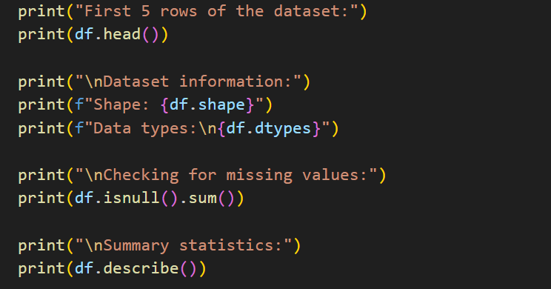
Output -
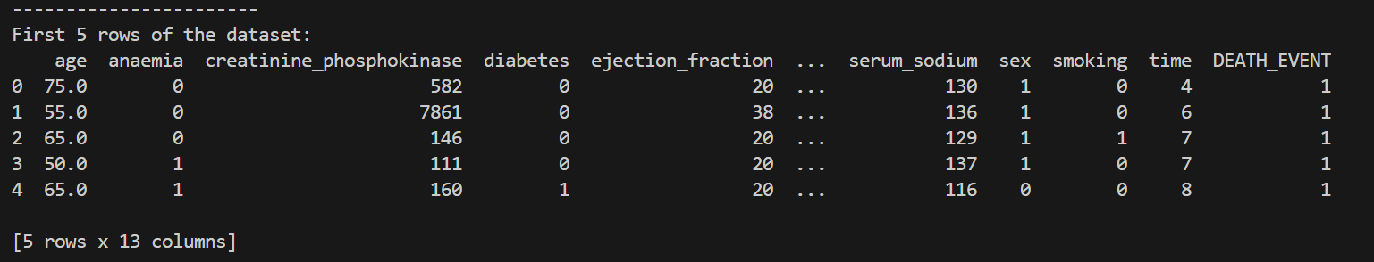
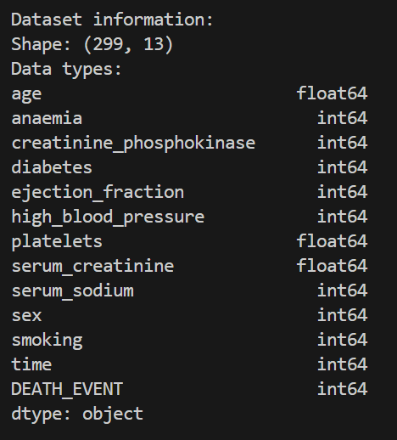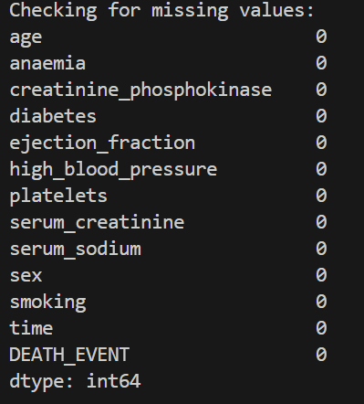
Summary statistics-
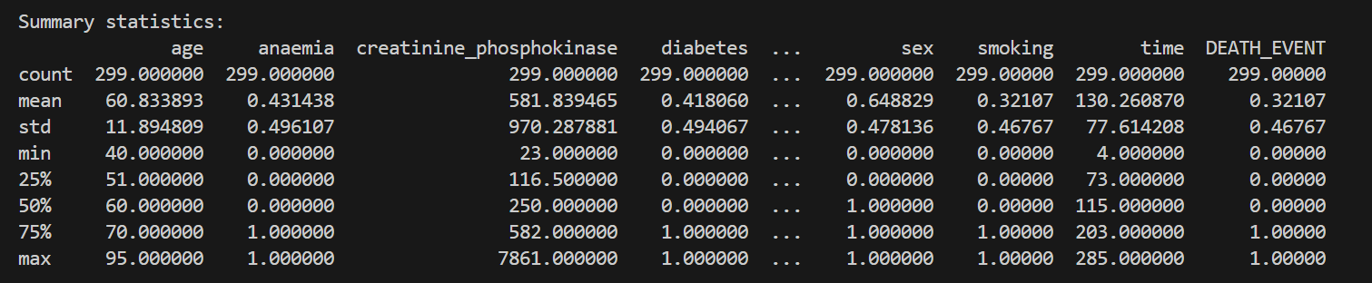 Overall balance of the dataset -
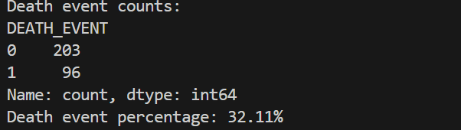

Step 2: Feature Selection and Preprocessing
Code -
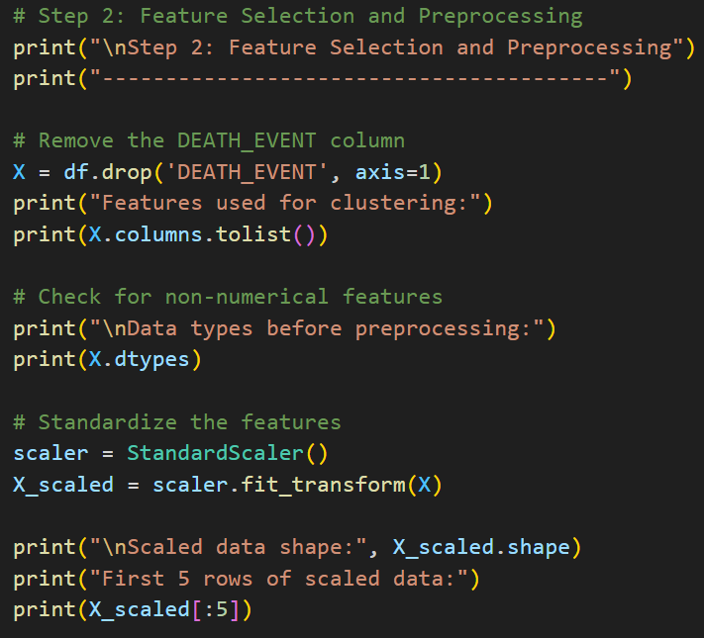
Output -
Drop the DEATH_EVENT column (not needed for unsupervised learning).

Ensure all remaining features are numerical.
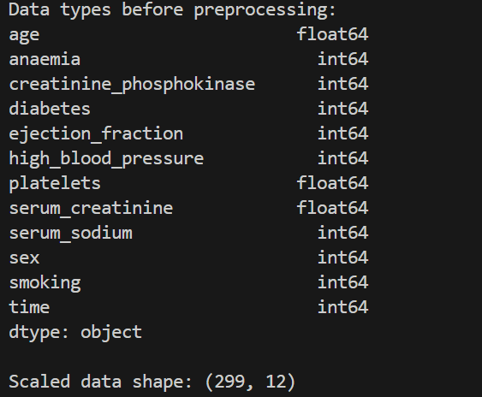

Confirm the shape and scaling of the data.
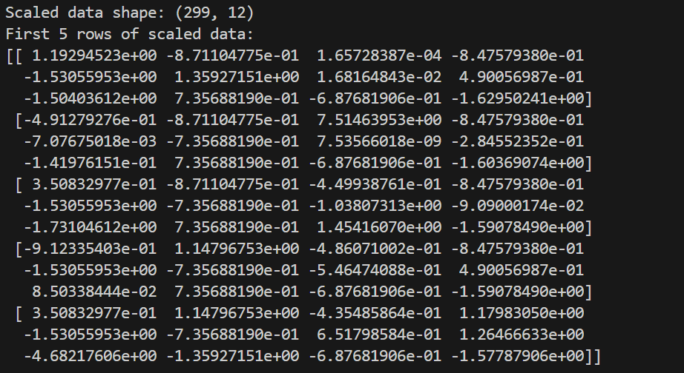

Step 3: Dimensionality Reduction with PCA

Code -
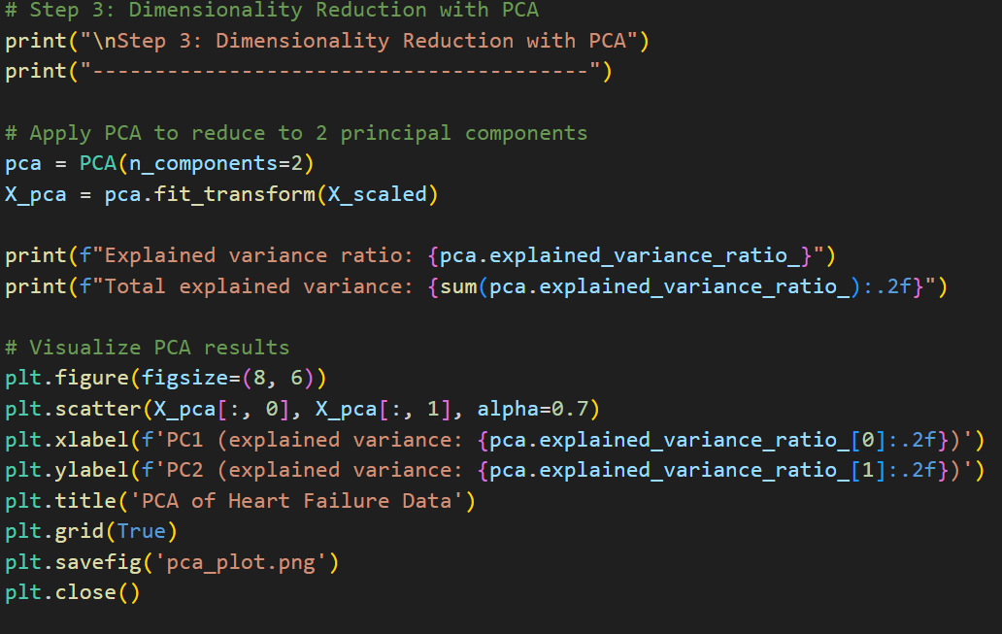

Output -
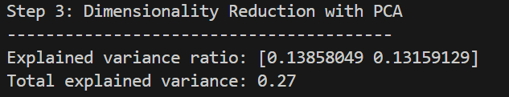

Step 4: Clustering with K-Means
Code -
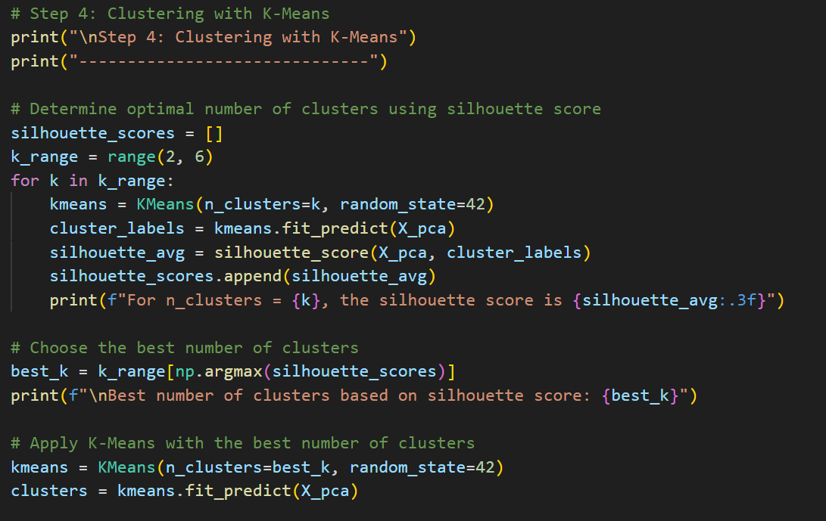
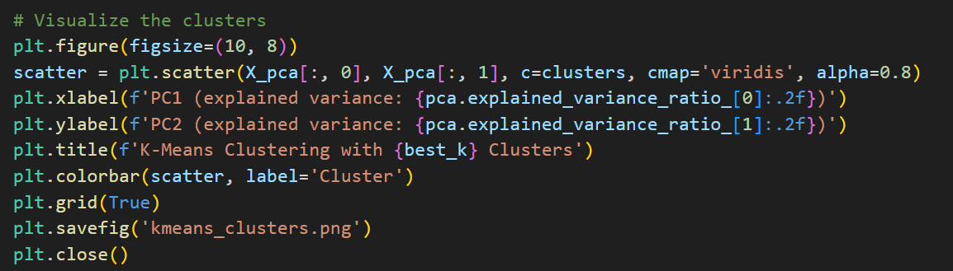

Output -
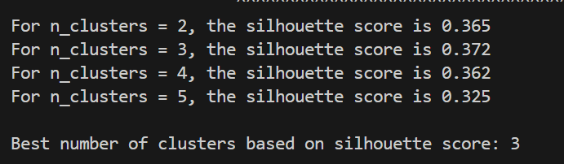

Step 5: Interpretation
Code -
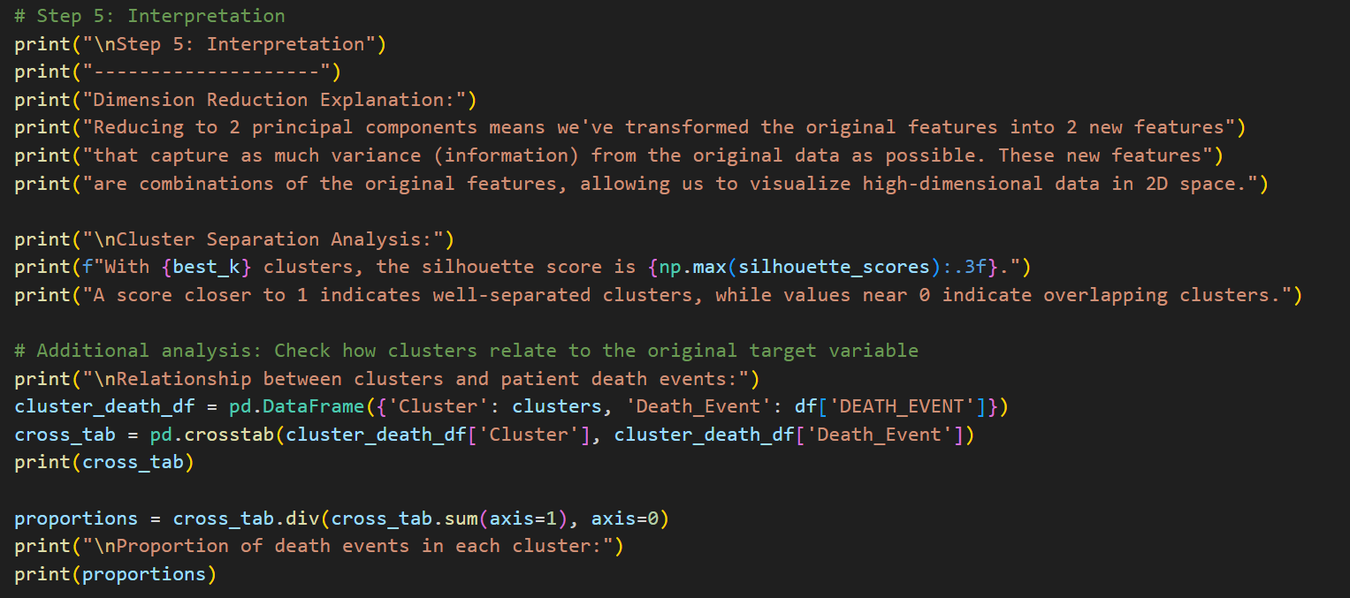

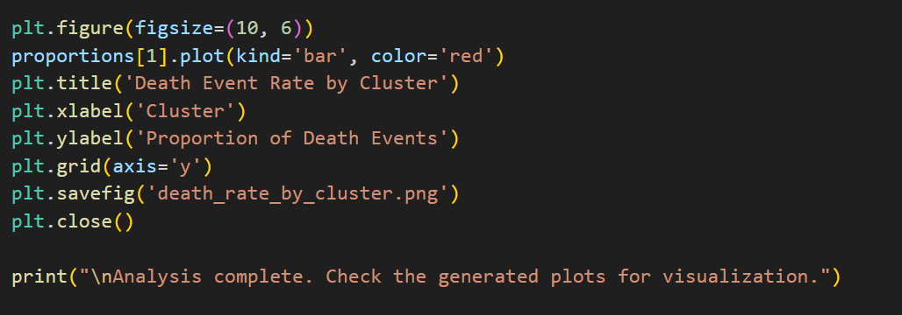

Output-
