Heart Failure Data Analysis using PCA and K-Means Clustering
Submitted By:Group 15
Step 1: Data Exploration:
We begin by importing and exploring the dataset using pandas, seaborn, and matplotlib.
- The dataset is loaded and the first few rows are displayed.
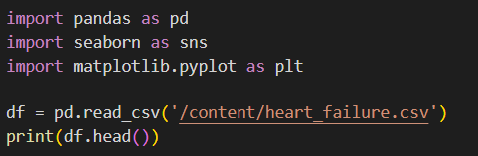
Output:
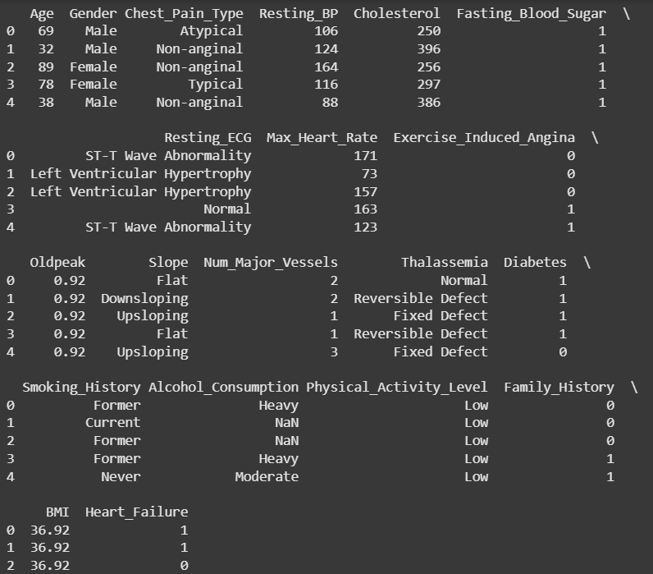
- Missing values are checked and there are 3350 missing values in Alcohol_Consumption column.
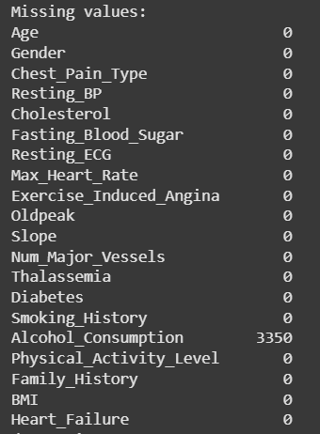
- Data types of all columns are confirmed.
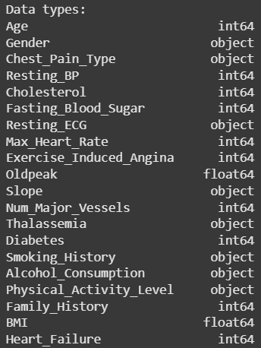
- Summary statistics are generated for all features.
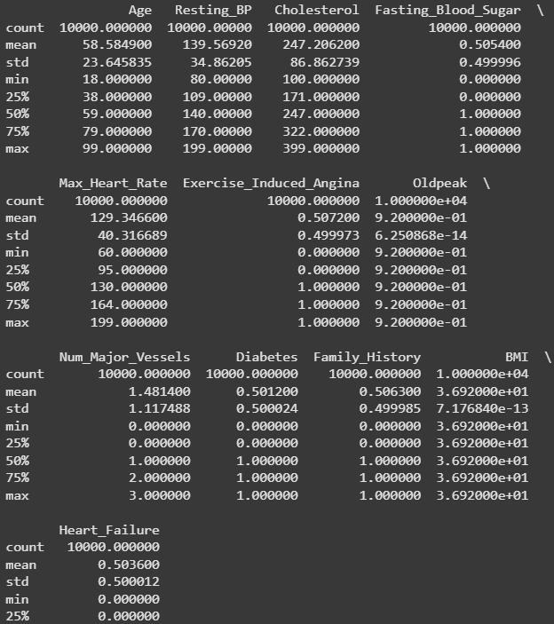
Feature Distributions:
We visualized the distributions for:
- Age
- Max_Heart_Rate
- Resting_BP
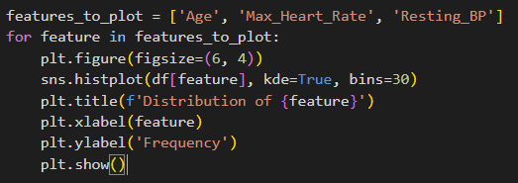
Output:
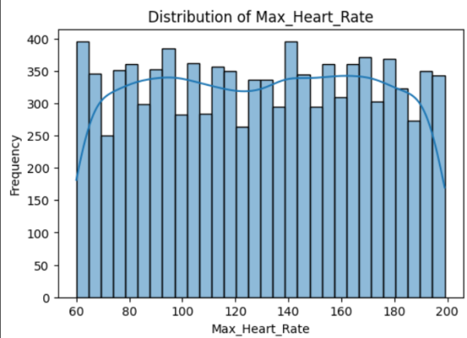
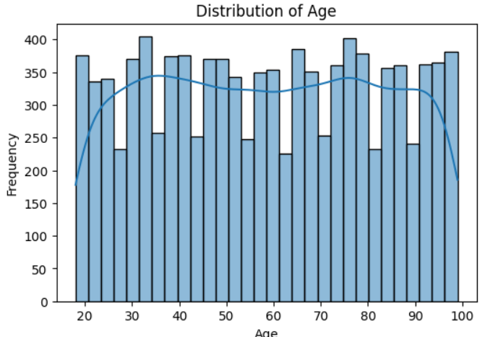

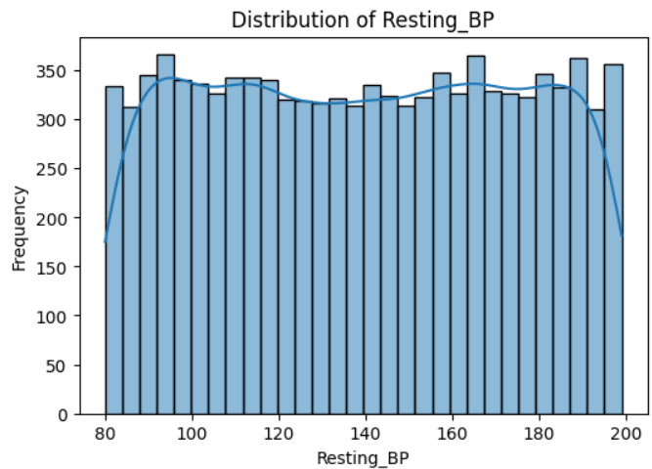

Class Distribution: The class balance of the target variable Heart_Failure was also visualized. The bar chart shows the number of patients who experienced heart failure compared to those who did not.
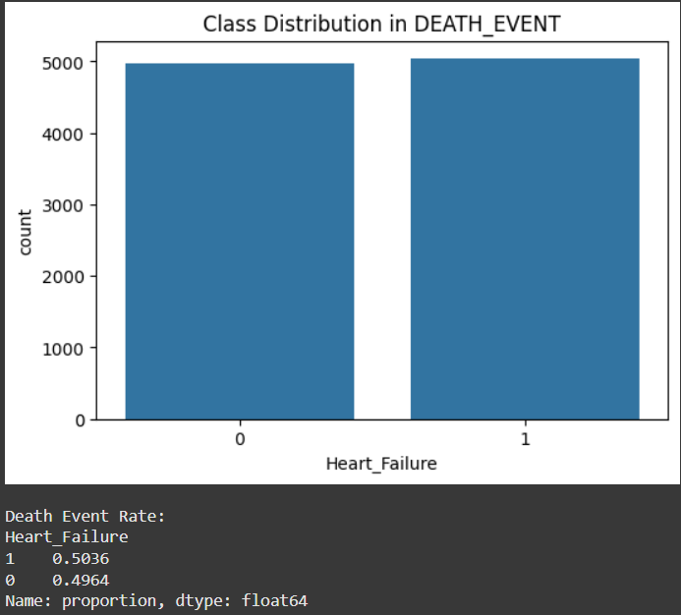
Step 2: Feature Selection and Preprocessing:
• Dropped the Heart_Failure (DEATH_EVENT) column as it's a label used for supervised learning and is not needed in unsupervised learning tasks.
• Converted all categorical features into numerical format using one-hot encoding to ensure compatibility with algorithms like PCA and clustering.
• Applied StandardScaler to standardize the features, transforming them to have a mean of 0 and a standard deviation of 1—essential for distance-based models.
• Verified the final shape of the dataset, confirming that the transformed dataset is fully numeric and ready for dimensionality reduction or clustering
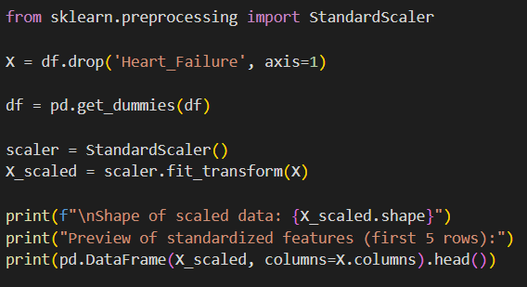
Output:
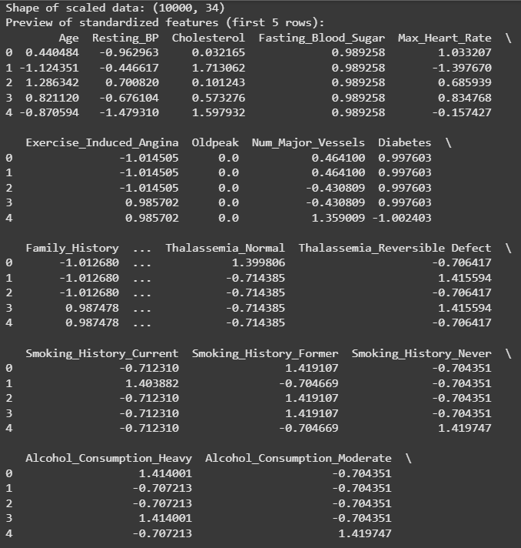
Step 3: Dimensionality Reduction with PCA:
• Applied Principal Component Analysis (PCA) to reduce the high-dimensional feature space to 2 principal components, enabling visualization and efficient clustering.
• Explained variance ratio was printed for each principal component to understand how much of the total variance is captured:
• Created a 2D scatter plot using the two principal components, visually representing the structure and distribution of the dataset in reduced dimensions.
• This reduction preserves the most critical variance in the dataset while simplifying its complexity for clustering or interpretation.
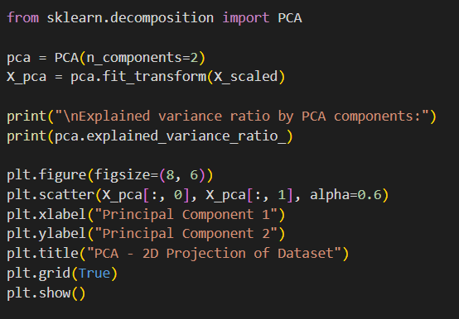
Output:
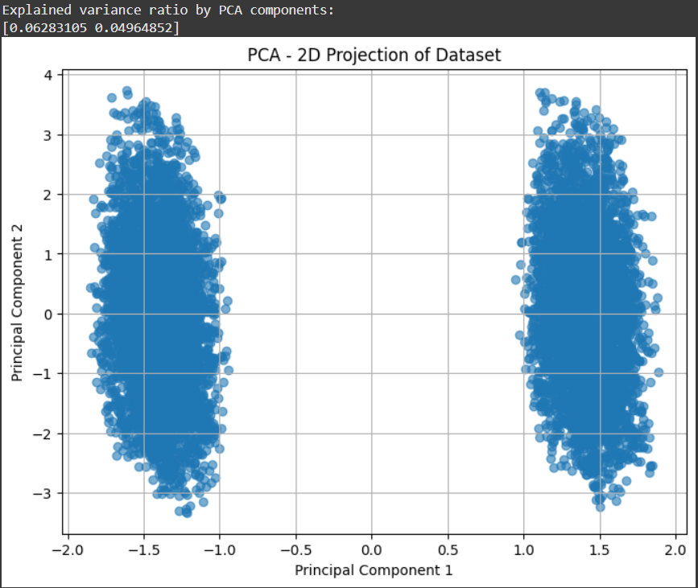
Step 4: Clustering with K-Means (with Elbow Method):
• Applied K-Means clustering to the PCA-reduced dataset (2 components), enabling efficient unsupervised segmentation of patients.
• Selected 2 clusters based on prior domain knowledge and exploratory analysis, assuming a potential split between high- and low-risk patient groups.
• Assigned a cluster label to each record, indicating its membership in one of the identified subgroups.
• Visualized the clusters using a PCA scatter plot, coloring each point according to its cluster assignment for intuitive interpretation of the segmentation.
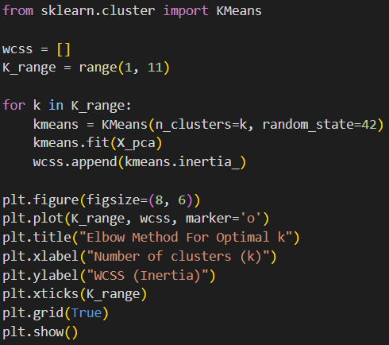
Output:
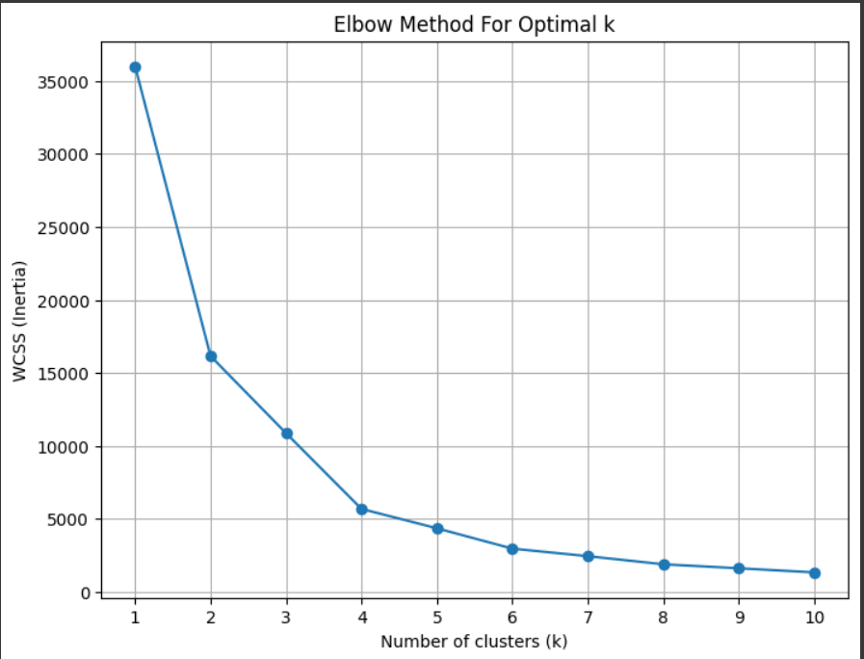
Step 5: Interpretation:
• Dimensionality Reduction:
Reducing the dataset to 2 principal components means transforming dozens of original features into just two new variables that capture most of the important variation in the data. It's like summarizing a detailed book into two key ideas while preserving the core message.
• Cluster Separation:
In the scatter plot of the PCA components, clusters appear as distinct groups of points. The more clearly separated these groups are, the more confidently we can say that K-Means has identified meaningful patterns.
• Real-World Relevance:
These clusters might correspond to actual patient subgroups, such as those at higher or lower risk of heart failure, or those sharing similar clinical traits. While not labeled, the separation hints at potential clinical insights worth further investigation with expert knowledge.
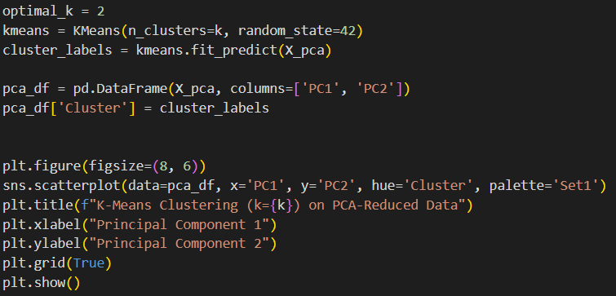
Output:
