HEART FAILURE ANALYSIS:
Unsupervised Learning with PCA and Clustering

Group 16
TEAM MEMBERS
Kwizera Jean Bosco
Marron Tarlue
Shreeshan Panda

Aim
To understand a clinical dataset of heart failure patients, perform dimensionality reduction using PCA, identify hidden patterns with K-Means clustering, and assess feature relevance for predicting heart failure outcomes.

1. Data Exploration
Most features were clean and numeric or categorically encodable. Oldpeak and BMI were found to be constant, offering no predictive power. The target variable (Heart_Failure) was slightly imbalanced.
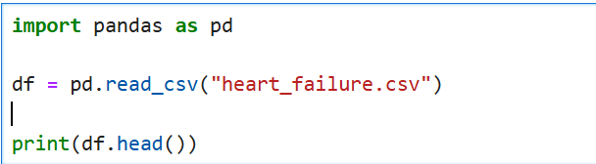
1.1 Load the dataset and display the first few rows.

Output
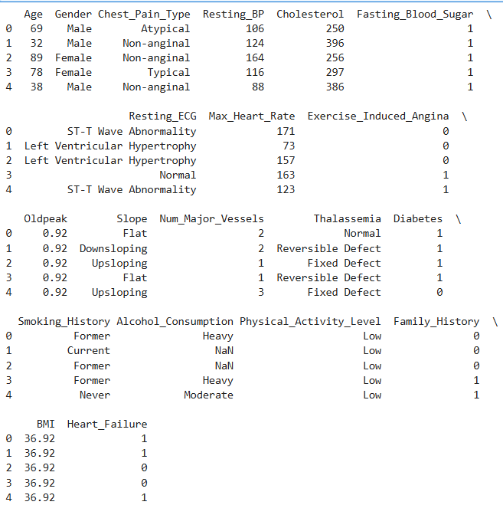

1.2 Check for missing values and confirm data types.
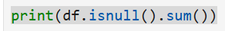
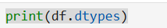

Output:
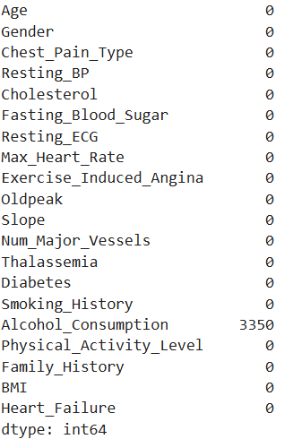
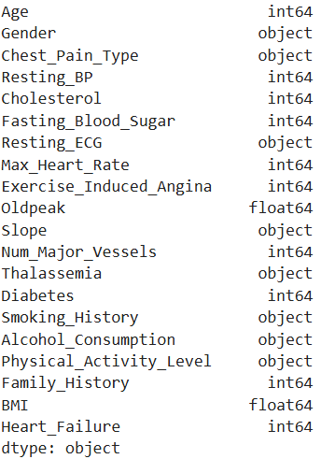
1.3 Generate summary statistics for each feature.
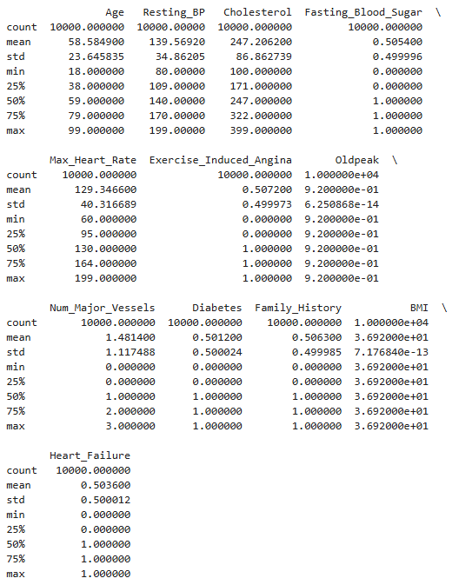
Output

  - Visualize distributions of key features (e.g., age, ejection_fraction, serum_creatinine).
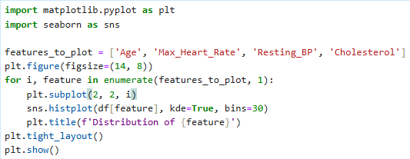
Output
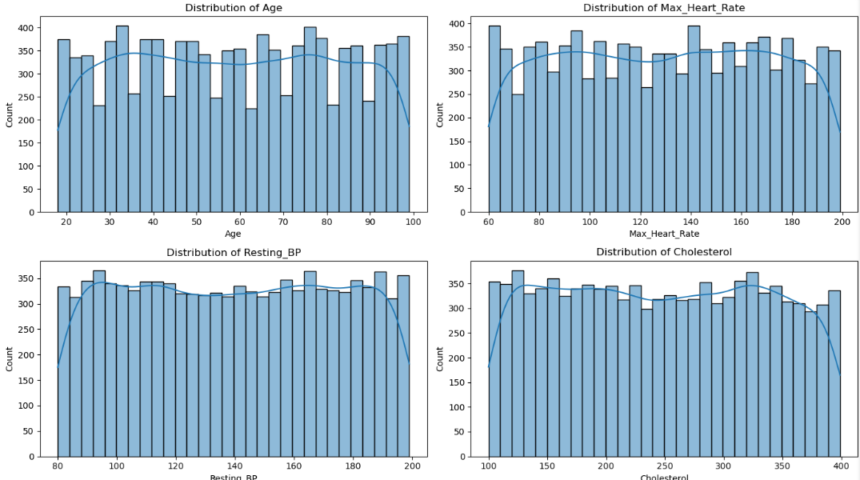
  - Comment on the overall balance of the dataset based on the DEATH_EVENT column.
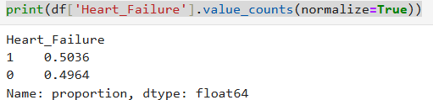
2. Feature Selection and Preprocessing
  - Drop the DEATH_EVENT column (not needed for unsupervised learning).
  - Ensure all remaining features are numerical.
  - Standardize the features using a method like StandardScaler.
  - Confirm the shape and scaling of the data.
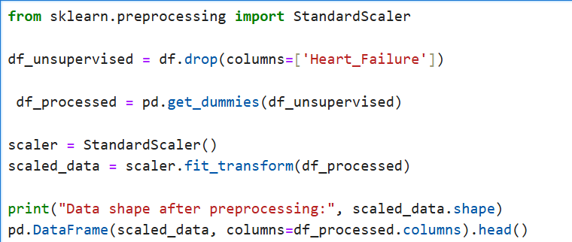

Output
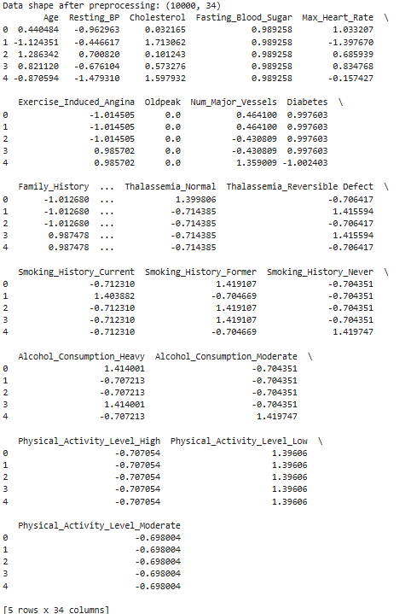
3. Dimensionality Reduction with PCA
  - Apply PCA to reduce the dataset to 2 principal components.
  - Print the explained variance ratio for each component.
  - Create a scatter plot using the two principal components.
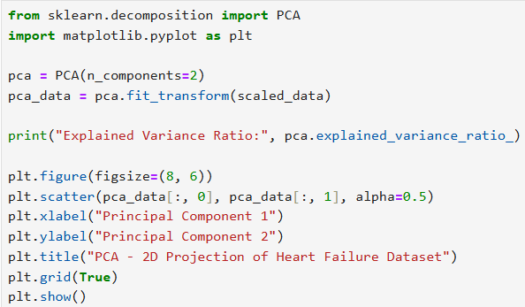
Output
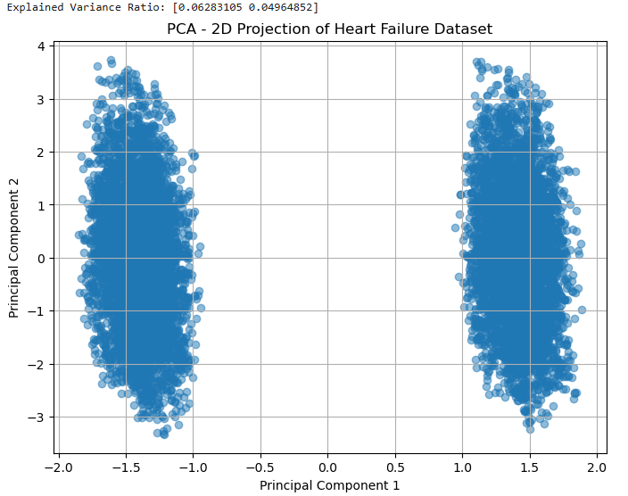
4. Clustering with K-Means
  - Use the PCA-reduced data to apply K-Means clustering.
  - Select an appropriate number of clusters (e.g., 2 or 3) and explain your choice.
  - Assign a cluster label to each record.
  - Visualize the clusters using the PCA plot with different colours for each cluster.
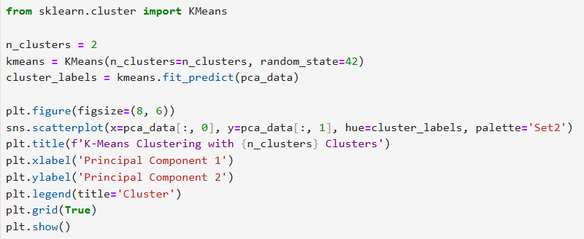

Output
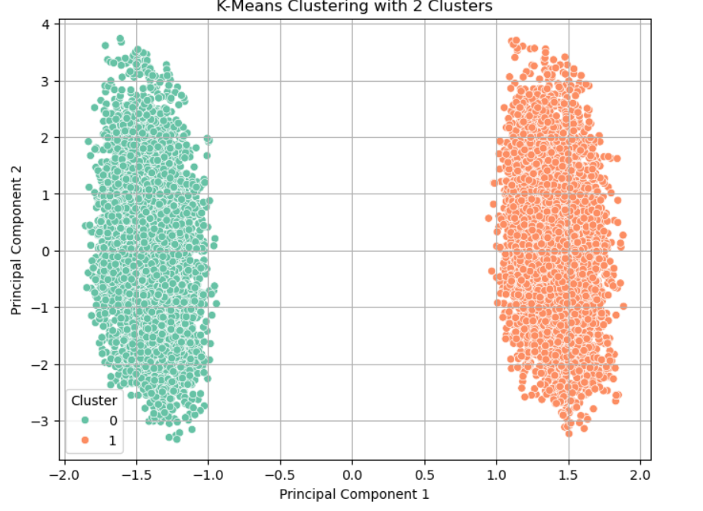
5. Interpretation
  - Explain what it means to reduce a dataset to 2 principal components in simple terms.
- Reducing to 2 principal components means transforming the data into two new dimensions that capture the most variance in the dataset. This makes it easier to visualize complex data and reduces noise.

  - Discuss how well the clusters are separated in your scatter plot.
- The clusters are well distinct in the PCA scatter plot. When the K-means have captured meaningful structures, it means that they have formed visually separated groups. If overlapping, the clustering may be weak.

  - Reflect on whether these clusters might correspond to real-world patient groups or clinical similarities.
- If clusters align well with known health indicators for example high cholesterol and low heart rate, they may represent real clinical profiles.

