
TOPIC:-
Heart Failure Dataset: Unsupervised Learning with PCA and Clustering

GROUP:-19

SUBMITTED BY
ASANI PATRA:-2201020246
ANUBHAB MOHAPATRA:-2201020247
MANOJ KUMAR SWAIN:-2201020252
JAY KUMAR MOHANTY:-2201020251

Heart Failure Dataset: Unsupervised Learning with PCA and Clustering

You are provided with a dataset containing clinical records of heart failure patients. Your task is to explore the dataset, reduce its dimensions using PCA, and identify patterns using K-Means clustering.
Step 1: Data Exploration
- Load the dataset and display the first few rows.
Code:-
import pandas as pd
import seaborn as sns

import matplotlib.pyplot as plt
df = pd.read_csv('heart_failure.csv')
print("First few rows of the dataset:")
print(df.head())

Output:-
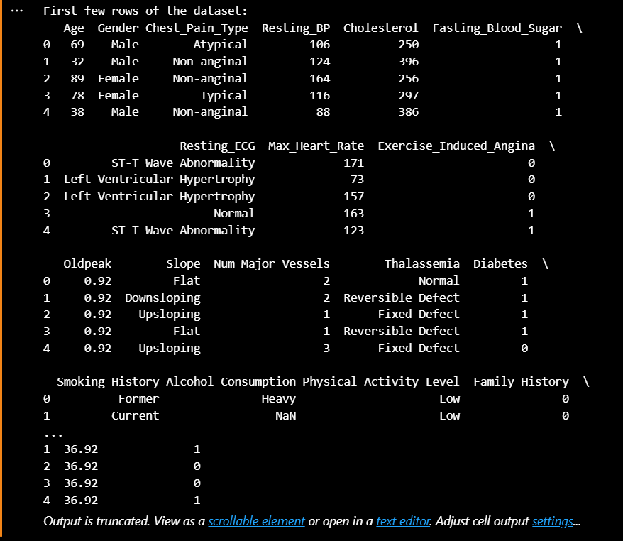

- Check for missing values and confirm data types.
Code:-
print("\nMissing values in the dataset:")
print(df.isnull().sum())
print("\nData types of each column:")
print(df.dtypes)

Output:-
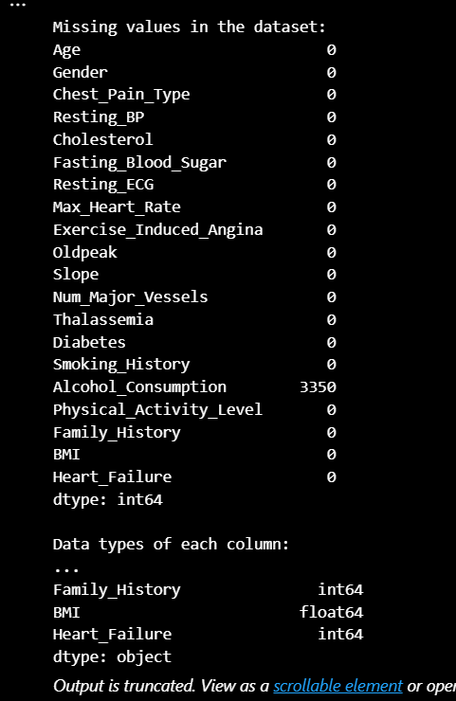

- Generate summary statistics for each feature.
Code:-
print("\nSummary statistics:")
print(df.describe())

Output:-
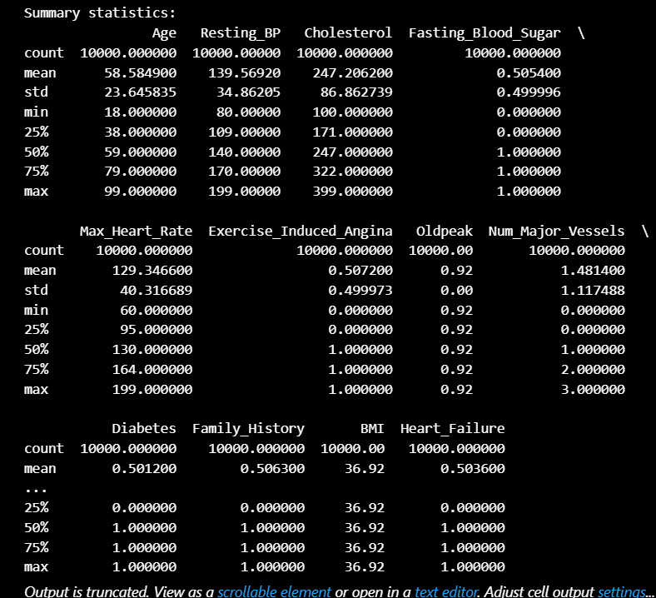

- Visualize distributions of key features (e.g., age, ejection_fraction, serum_creatinine).
Code:-
key_features = ['Age', 'Resting_BP', 'Cholesterol'] # Corrected column names
for feature in key_features:
plt.figure(figsize=(4, 4))
sns.histplot(df[feature], kde=True, bins=20)
plt.title(f'Distribution of {feature}')
plt.xlabel(feature)
plt.ylabel('Frequency')
plt.show()
Output:-
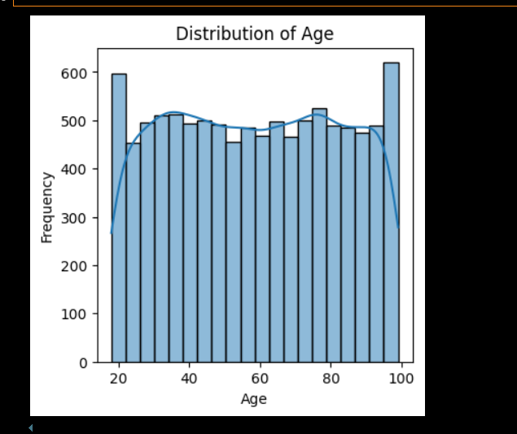
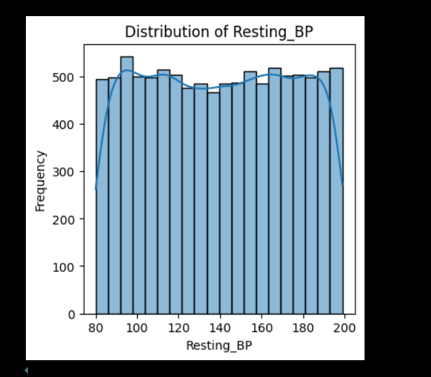

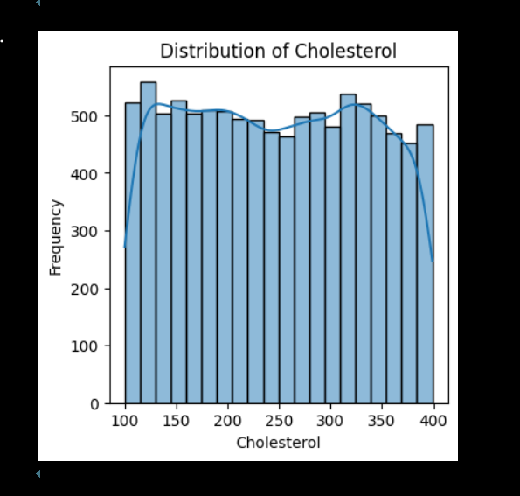

- Comment on the overall balance of the dataset based on the DEATH_EVENT column.
Code:-
plt.figure(figsize=(4, 4))
sns.countplot(x='Heart_Failure', data=df)
plt.title('Balance of the DEATH_EVENT column')
plt.xlabel('DEATH_EVENT')
plt.ylabel('Count')
plt.show()

Output:-
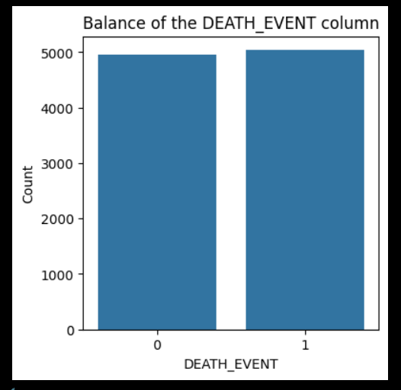

Step 2: Feature Selection and Preprocessing
- Drop the DEATH_EVENT column (not needed for unsupervised learning).
- Ensure all remaining features are numerical.
- Standardize the features using a method like StandardScaler.
- Confirm the shape and scaling of the data.
Code:-
from sklearn.preprocessing import StandardScaler
df_unsupervised = df.drop(columns=['Heart_Failure'])
numerical_features = df_unsupervised.select_dtypes(include=['int64', 'float64'])
scaler = StandardScaler()
scaled_features = scaler.fit_transform(numerical_features)
df_scaled = pd.DataFrame(scaled_features, columns=numerical_features.columns)
print("Shape of the scaled data:", df_scaled.shape)
print("\nFirst few rows of the scaled data:")
print(df_scaled.head())
Output:-
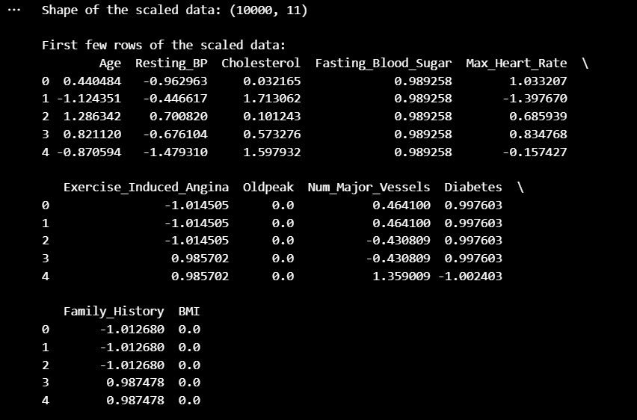
Step 3: Dimensionality Reduction with PCA
- Apply PCA to reduce the dataset to 2 principal components.
- Print the explained variance ratio for each component.
- Create a scatter plot using the two principal components.
Code:-
from sklearn.decomposition import PCA
pca = PCA(n_components=2)
principal_components = pca.fit_transform(df_scaled)
df_pca = pd.DataFrame(data=principal_components, columns=['Principal Component 1', 'Principal Component 2'])

print("Explained variance ratio for each component:")
print(pca.explained_variance_ratio_)

plt.figure(figsize=(8, 6))
plt.scatter(df_pca['Principal Component 1'], df_pca['Principal Component 2'], alpha=0.5)
plt.title('PCA Scatter Plot')
plt.xlabel('Principal Component 1')
plt.ylabel('Principal Component 2')
plt.grid()
plt.show()
Output:-
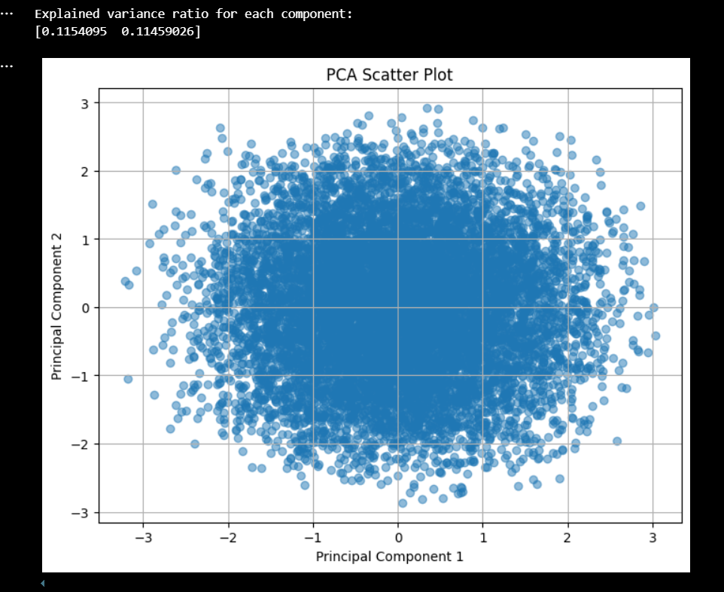
Step 4: Clustering with K-Means
- Use the PCA-reduced data to apply K-Means clustering.
- Select an appropriate number of clusters (e.g., 2 or 3) and explain your choice.
- Assign a cluster label to each record.
- Visualize the clusters using the PCA plot with different colors for each cluster.
Code:-
from sklearn.cluster import KMeans

n_clusters = 3
kmeans = KMeans(n_clusters=n_clusters, random_state=42)
cluster_labels = kmeans.fit_predict(df_pca)

df_pca['Cluster'] = cluster_labels
plt.figure(figsize=(8, 6))
for cluster in range(n_clusters):
cluster_data = df_pca[df_pca['Cluster'] == cluster]
plt.scatter(cluster_data['Principal Component 1'], cluster_data['Principal Component 2'], label=f'Cluster {cluster}', alpha=0.6)

plt.title('K-Means Clustering on PCA-Reduced Data')
plt.xlabel('Principal Component 1')
plt.ylabel('Principal Component 2')
plt.legend()
plt.grid()
plt.show()
Output:-
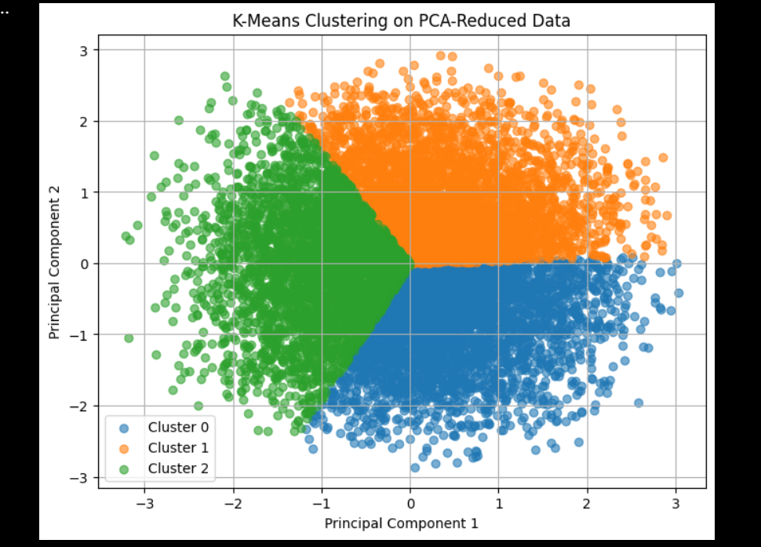
Step 5: Interpretation
- Explain what it means to reduce a dataset to 2 principal components in simple terms.
ANS:-
Explaining PCA Reduction (What does "reducing to 2 principal components" mean?):
- The Problem: Your original dataset had many features (columns like age, sex, ejection_fraction, creatinine, etc. - 12 features after dropping DEATH_EVENT). It's hard to visualize or find patterns in data with so many dimensions. PCA's Solution: PCA (Principal Component Analysis) is a technique to summarize those original 12 features into a smaller number of new, artificial features called "Principal Components" (PCs). We chose to create just 2 PCs (PC1 and PC2).
- In Simple Terms: Imagine describing 12 different aspects of a patient with just two main summary scores (PC1 and PC2) that still capture a good chunk of the important differences between patients. The output told you how much of the original variance (information) these two PCs managed to keep (e.g., maybe 30-40% - the exact number was printed in Step 3).
- Discuss how well the clusters are separated in your scatter plot.
ANS:-
Discussing Cluster Separation (How well did K-Means group the data?):
- The Goal: K-Means tried to divide the data points (patients) on your 2D PCA plot into distinct groups (clusters). We asked it to find k=2 groups. What to Look For: You need to look at the scatter plot generated at the end of Step 4, where points are colored by their assigned cluster (e.g., Cluster 0 and Cluster 1) and the cluster centers (centroids) are marked (often with an 'X').
- In Simple Terms: Look at the colored dots on the graph. Are the colors nicely separated, or are they all mixed up? This tells you if the computer algorithm (K-Means) could find clear dividing lines between groups of patients based on their summary scores (PC1, PC2).
- Reflect on whether these clusters might correspond to real-world patient groups or clinical similarities.
ANS:-
Reflecting on Potential Real-World Meaning (Could these clusters represent actual patient types?):
- The Key: Remember, the clusters were formed only using the clinical measurements (age, lab results, etc.) represented by PC1 and PC2. The algorithm didn't know who survived or died (DEATH_EVENT was removed). What Clusters Represent: The clusters represent groups of patients who have similar profiles according to the combined information in PC1 and PC2. For example, Cluster 0 might contain patients who tend to have high values for certain original features (leading to specific PC1/PC2 scores), while Cluster 1 contains patients with different patterns. Potential Connection: Could these groups correspond to something clinically meaningful? Maybe. One cluster might loosely correspond to patients with more advanced disease indicators, while the other corresponds to those with less severe indicators, even though we didn't explicitly use severity or outcome labels. They might reflect different underlying causes or risk profiles.
- In Simple Terms: The computer found groups of patients with similar measurement patterns. These patterns might be related to different health statuses or types of heart failure, but we can't be sure without more investigation and expert input. The clustering just points out potential structures in the data itself.

