Cranes at CVR Q18
Heart Failure Dataset: Unsupervised Learning with PCA and Clustering

Step 1: Data Exploration
- Load the dataset and display the first few rows.
- Check for missing values and confirm data types.
- Generate summary statistics for each feature.
- Visualize distributions of key features (e.g., age, ejection_fraction, serum_creatinine).
- Comment on the overall balance of the dataset based on the DEATH_EVENT column.
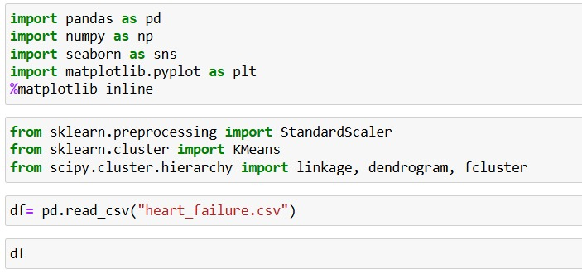

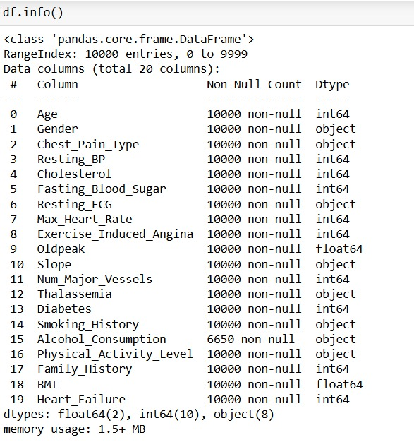
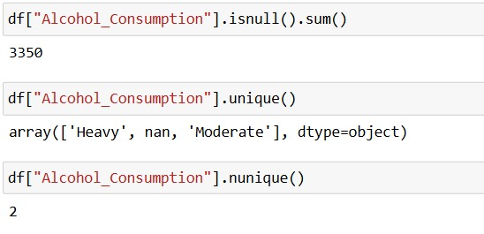

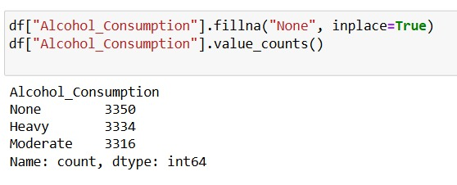

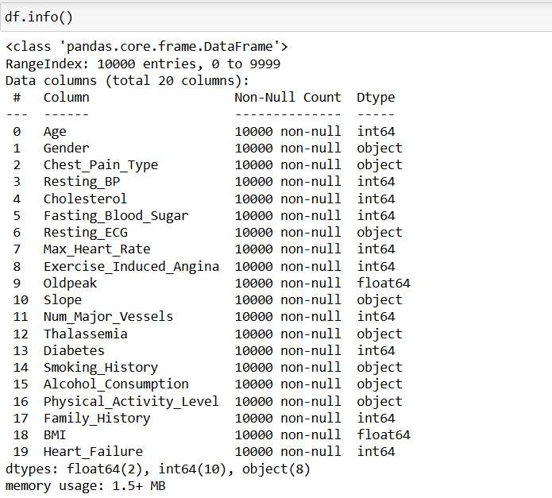

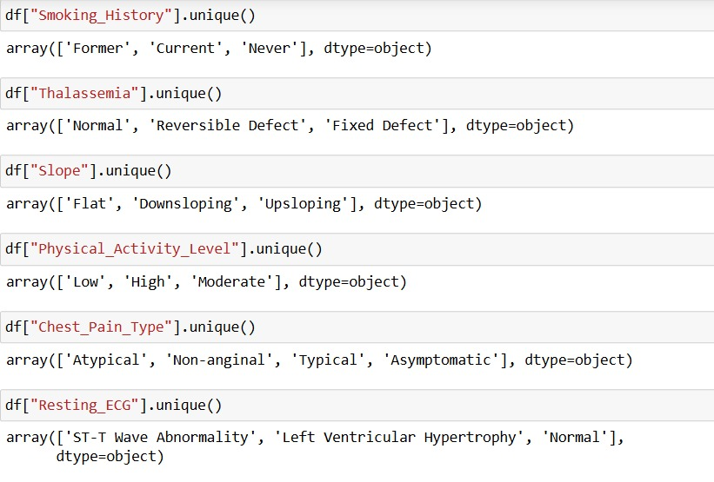
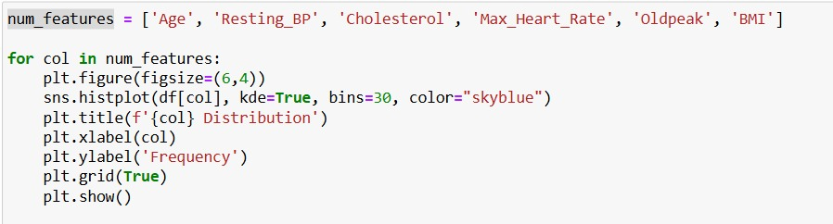
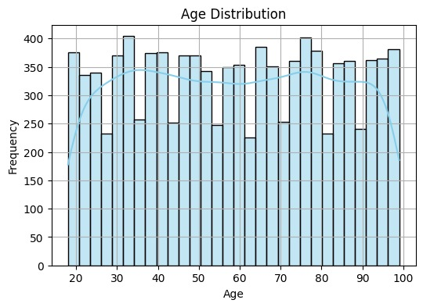
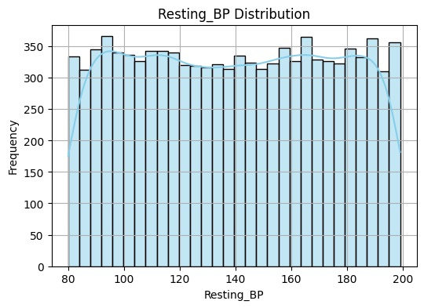

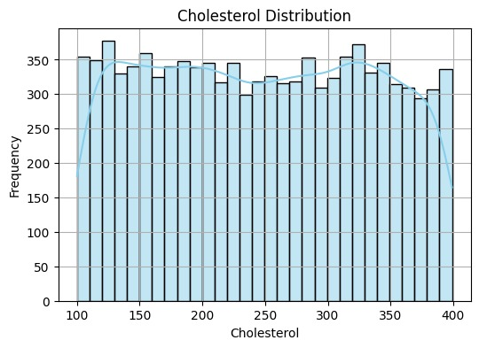
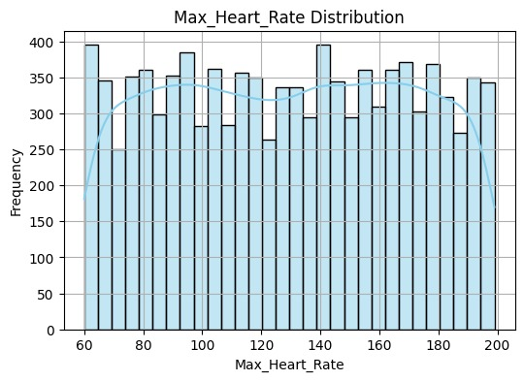

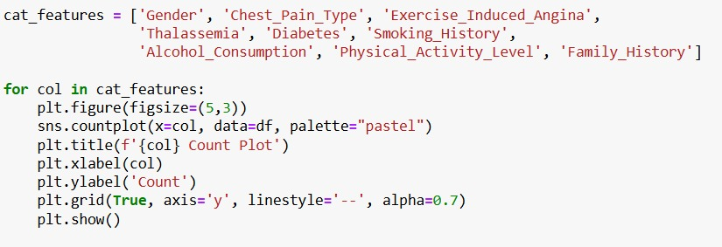

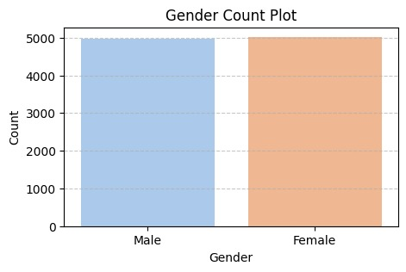
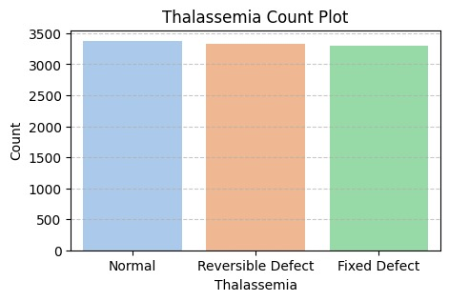

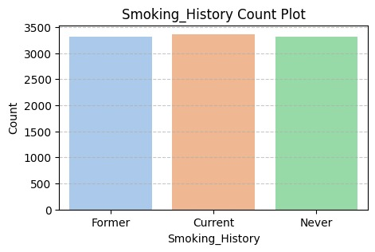
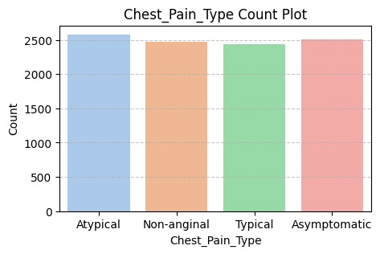

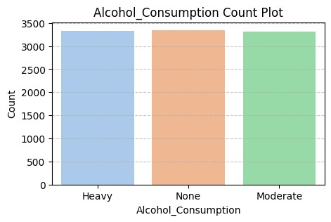
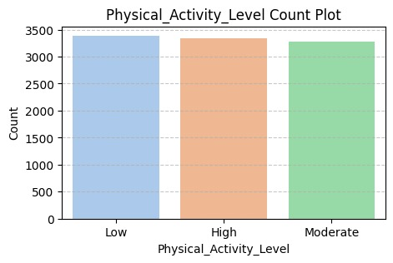

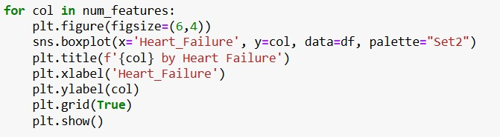
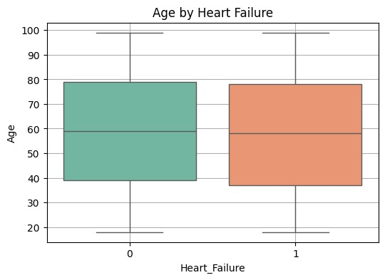
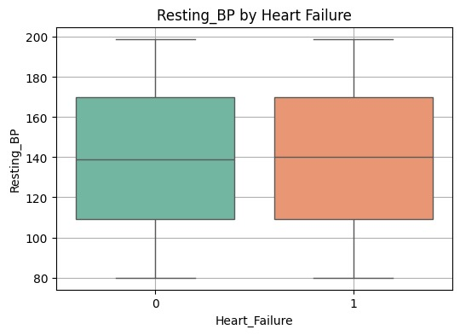

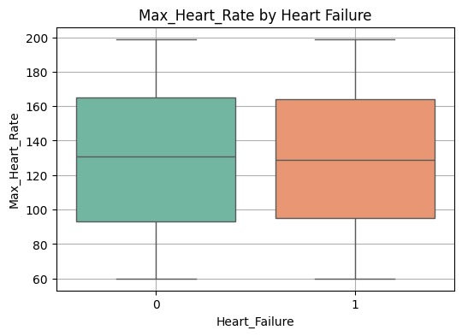
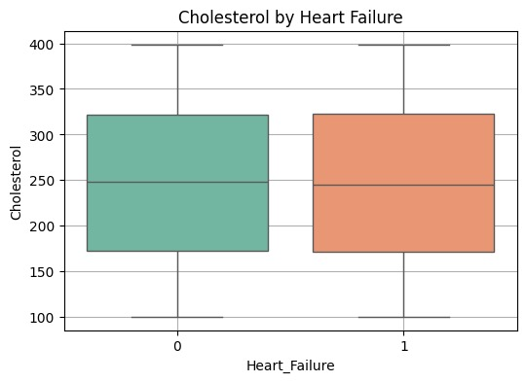

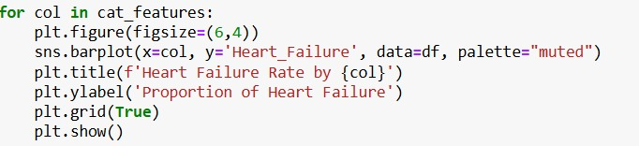

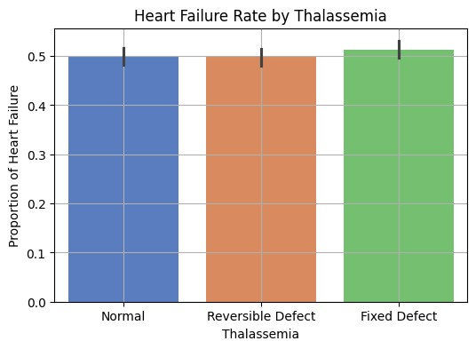
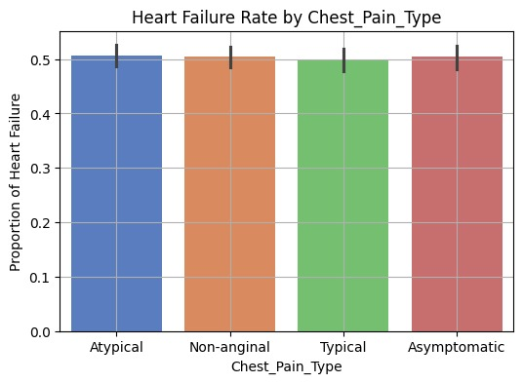

LABEL ENCODING CATGORICAL FEATURES :

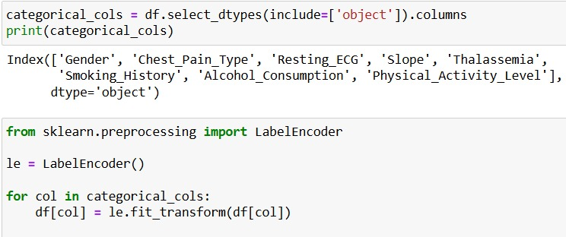
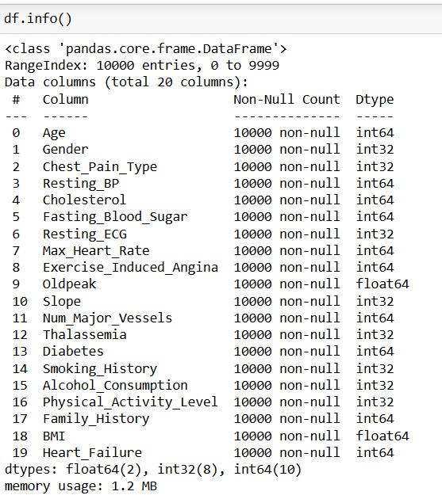

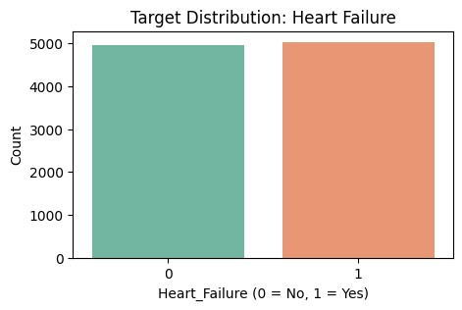

Step 2: Feature Selection and Preprocessing
- Drop the DEATH_EVENT column (not needed for unsupervised learning).
- Ensure all remaining features are numerical.
- Standardize the features using a method like StandardScaler.
- Confirm the shape and scaling of the data.

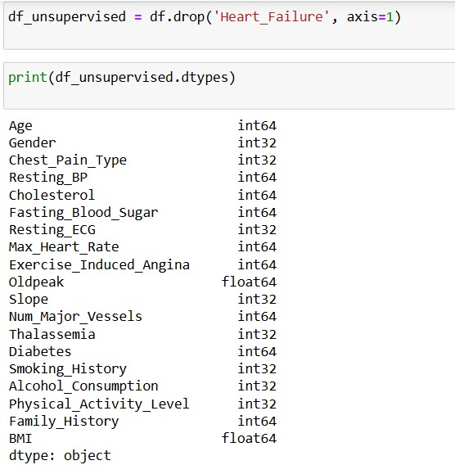

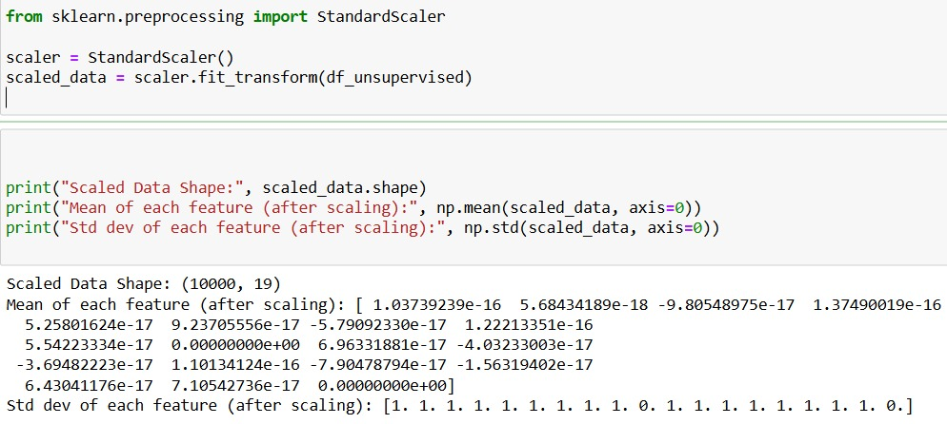

Step 3: Dimensionality Reduction with PCA
- Apply PCA to reduce the dataset to 2 principal components.
- Print the explained variance ratio for each component.
- Create a scatter plot using the two principal components.

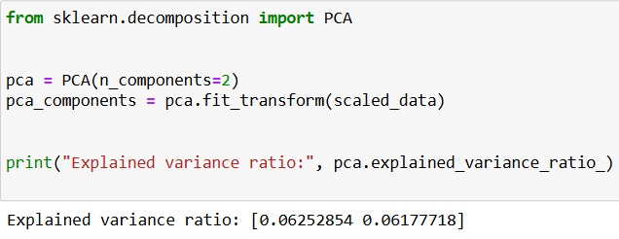

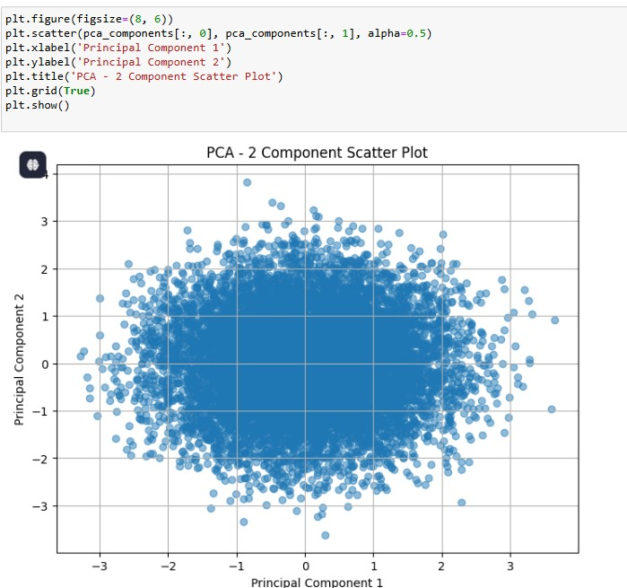

Step 4: Clustering with K-Means
- Use the PCA-reduced data to apply K-Means clustering.
- Select an appropriate number of clusters (e.g., 2 or 3) and explain your choice.
- Assign a cluster label to each record.
- Visualize the clusters using the PCA plot with different colors for each cluster.

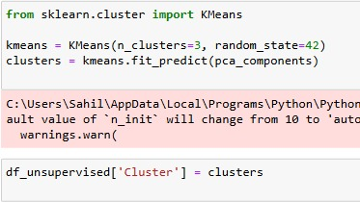
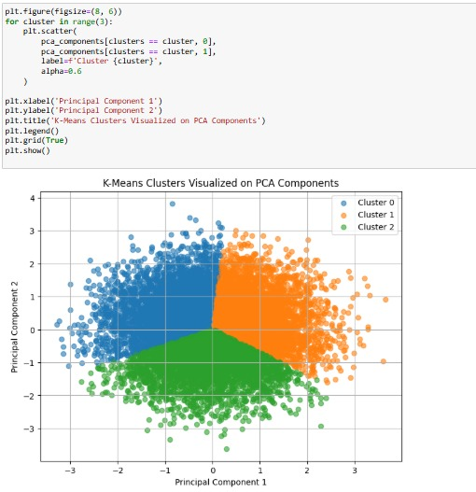

Step 5: Interpretation
- Explain what it means to reduce a dataset to 2 principal components in simple terms.
- Discuss how well the clusters are separated in your scatter plot.
- Reflect on whether these clusters might correspond to real-world patient groups or clinical similarities.

- What does it mean to reduce a dataset to 2 principal components?
Reducing a dataset to 2 principal components means we're simplifying a complex dataset that might have had many features (or dimensions) into just two new variables, called Principal Component 1 and Principal Component 2. These two components capture the most important patterns or variance in the original data. Think of it as taking a high-dimensional dataset and projecting it onto a flat 2D surface in such a way that we can still see the main structure or differences in the data. This makes it easier to visualize and analyze.

- How well are the clusters separated in the scatter plot?
Looking at the scatter plot, the clusters are reasonably well-separated, especially between Cluster 0 (blue) and Cluster 2 (green). Cluster 1 (orange) overlaps a bit with both, particularly in the center, but still forms a distinct group. While there is some mixing at the boundaries, the clustering does seem to capture three general groupings in the data.

3. Do these clusters correspond to real-world patient groups or clinical similarities?
It's possible. If this data came from a medical context—say, patient health metrics or diagnostic features—then the clusters might represent different patient profiles. For example, one cluster could represent patients with mild symptoms, another with moderate, and another with severe. However, since PCA reduces dimensionality and K-Means clusters based on distances, these groupings are purely mathematical. To truly know if they correspond to meaningful clinical categories, we would need to interpret the original features and possibly compare with known labels or expert clinical knowledge. Still, this is a useful starting point for exploring potential patterns or subgroups in medical data.

SUBMITTED BY:

SAHIL SINGH: CL20250106019665113

SHRUTI SINHA: CL2025010601873240

SOUMYAJIT BANERJEE: CL2025010601873643

SURAJ VERMA: CL2025010601899149

