C.V. RAMAN GLOBAL UNIVERSITY
BHUBANESWAR, ODISHA-752054
DEPARTMENT OF COMPUTER SCIENCE & ENGINEERING

DS&AI
TOPIC:- Heart Failure Dataset: Unsupervised Learning with PCA and Clustering
GROUP:-3
NAME | CRANES REGD. NO.
SPARSH ATHGHARA | CL202501060196941
SOMIYA SINGH | CL2025010601911854

Heart Failure Dataset: Unsupervised Learning with PCA and Clustering
Step 1: Data Exploration
- Load the dataset and display the first few rows.
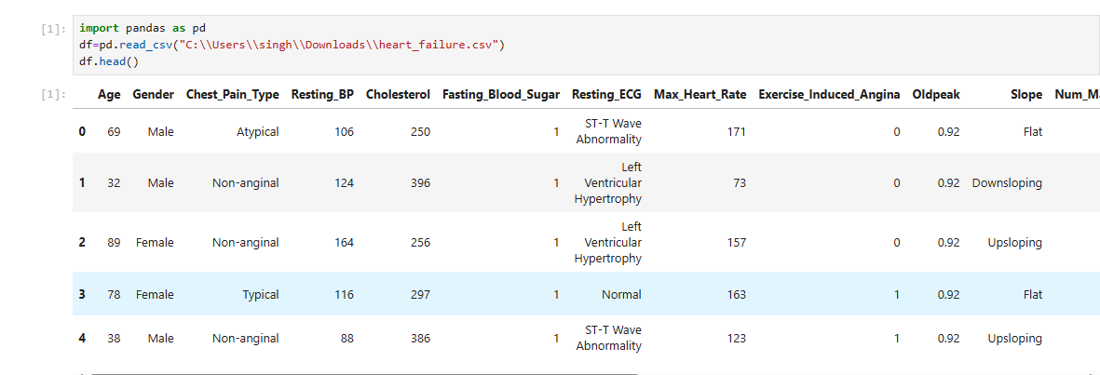
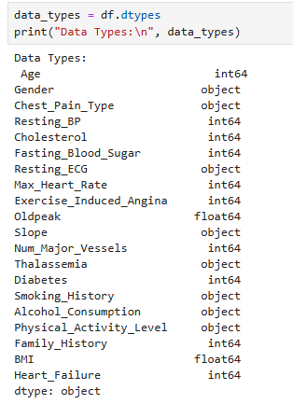
- Check for missing values and confirm data types.

- Generate summary statistics for each feature.
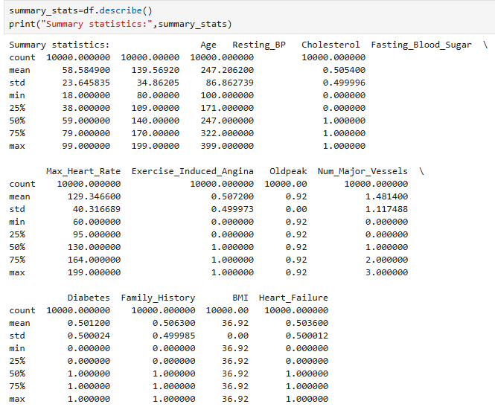
- Visualize distributions of key features (e.g., age, ejection_fraction, serum_creatinine).
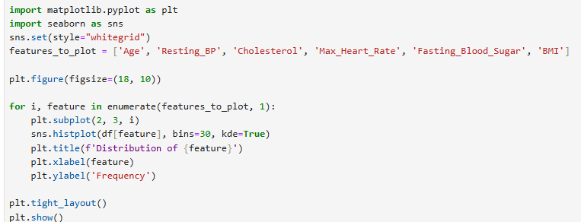

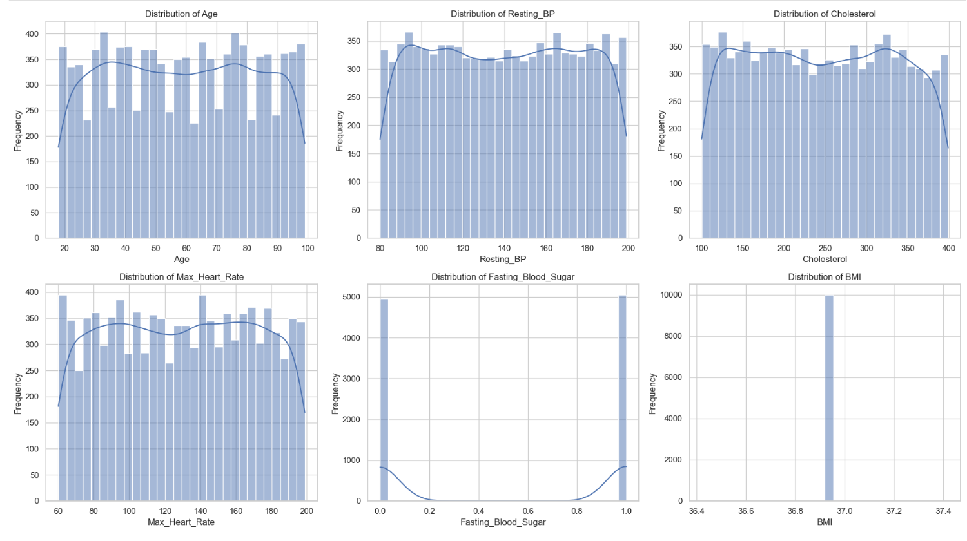
- Comment on the overall balance of the dataset based on the DEATH_EVENT column.
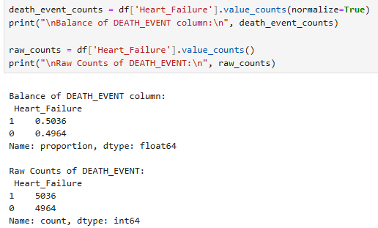
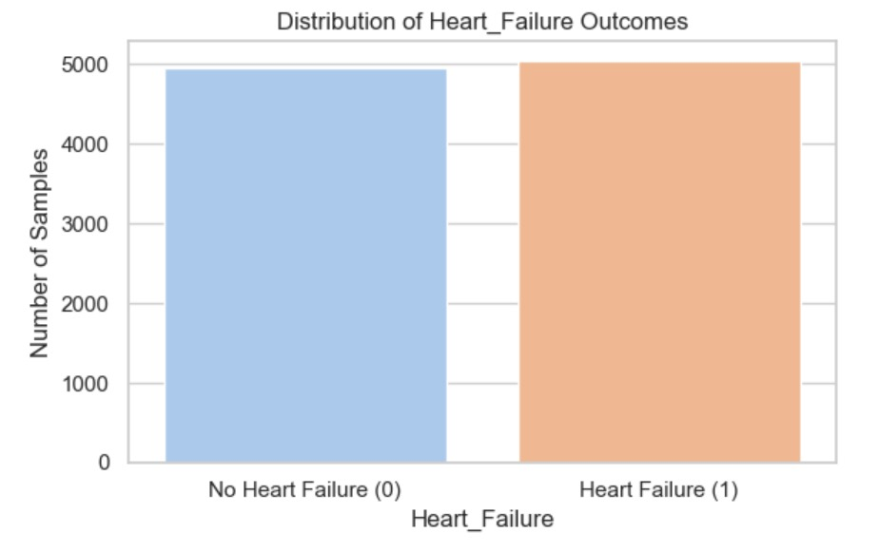

Step 2: Feature Selection and Preprocessing
- Drop the DEATH_EVENT column (not needed for unsupervised learning).
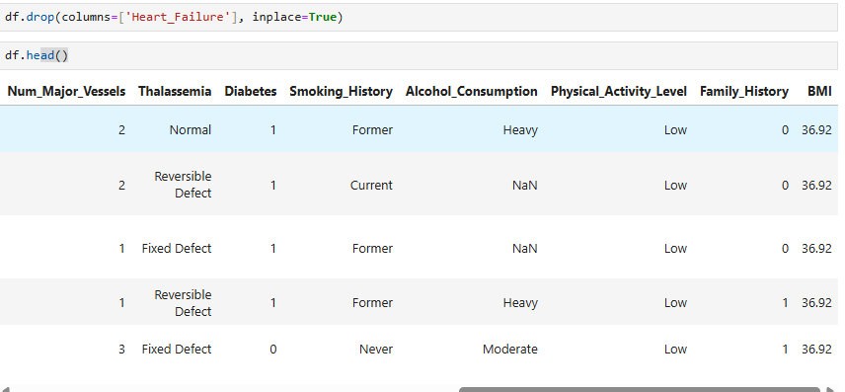
- Ensure all remaining features are numerical.
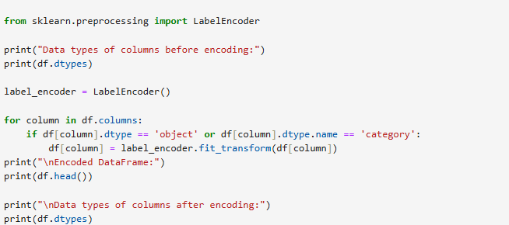
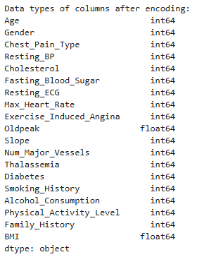
- Standardize the features using a method like StandardScaler.
- Confirm the shape and scaling of the data.
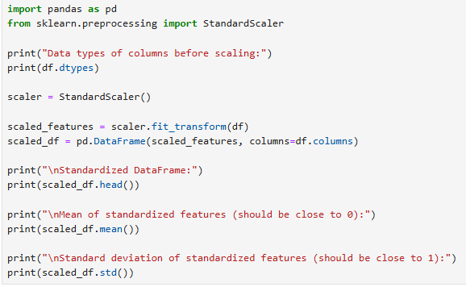
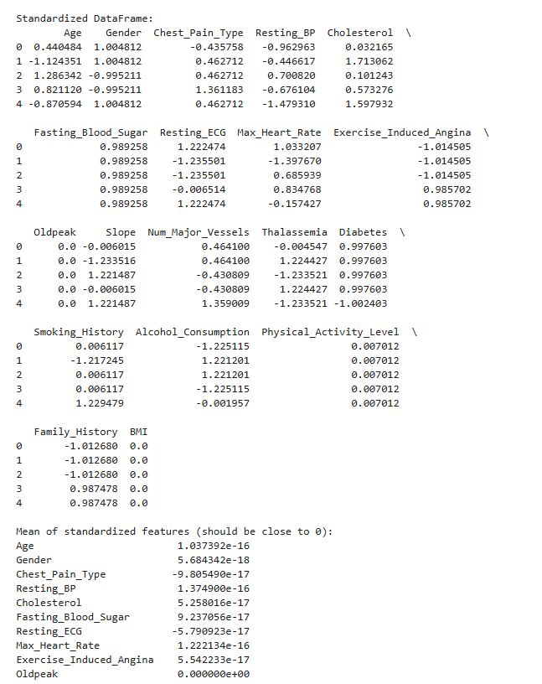
Step 3: Dimensionality Reduction with PCA
- Apply PCA to reduce the dataset to 2 principal components.
- Print the explained variance ratio for each component.
- Create a scatter plot using the two principal components.
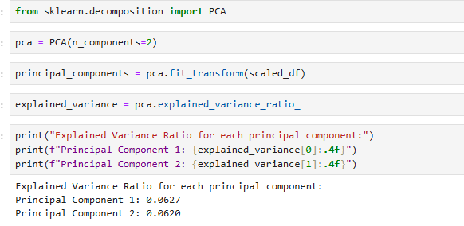
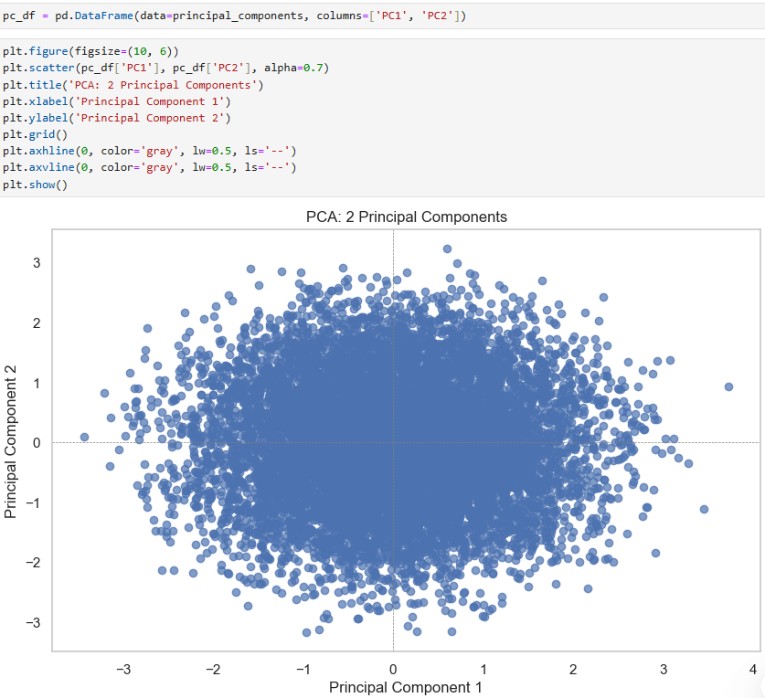
Step 4: Clustering with K-Means
- Use the PCA-reduced data to apply K-Means clustering.
- Select an appropriate number of clusters (e.g., 2 or 3) and explain your choice.
- Assign a cluster label to each record.
- Visualize the clusters using the PCA plot with different colors for each cluster.
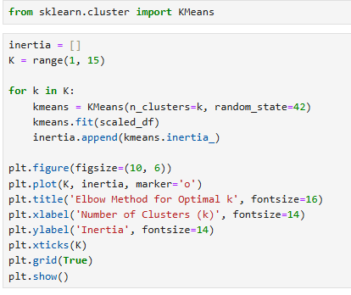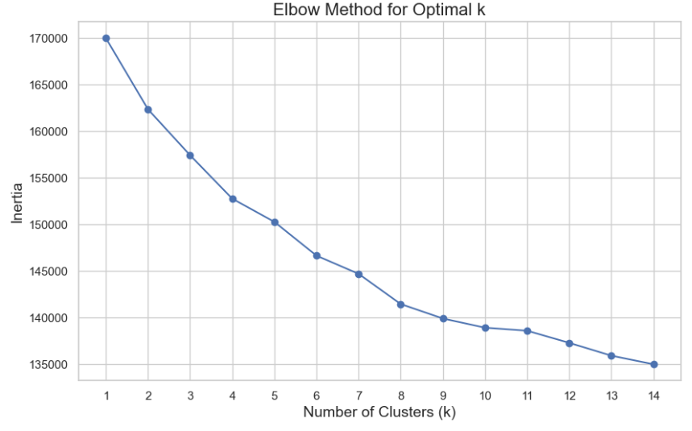
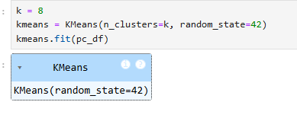
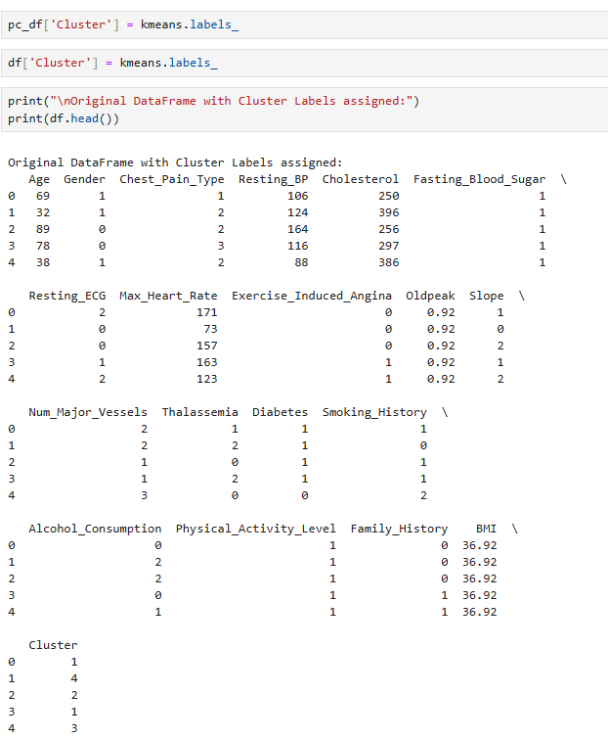

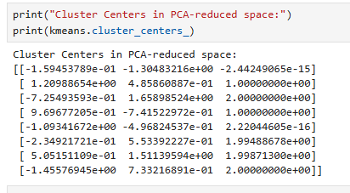

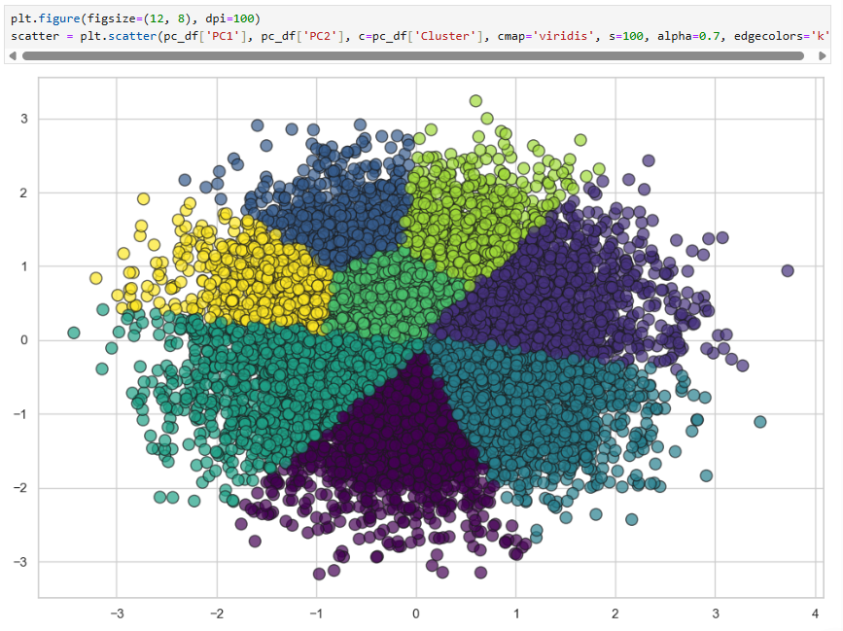

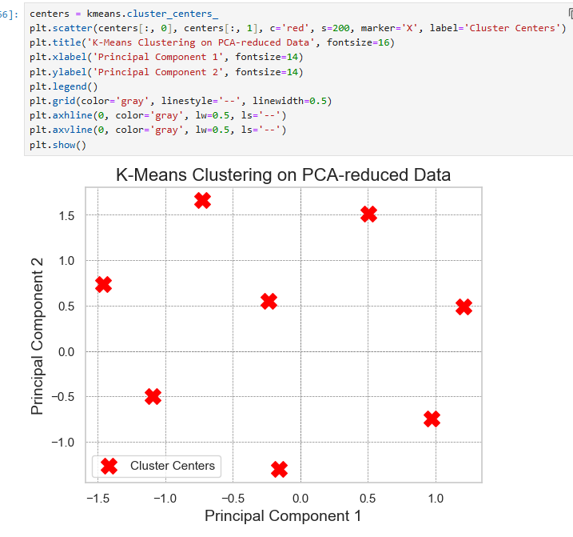
We simplify many measurements into 2 key summaries to understand the data better.-

