Topic :
Heart Failure Dataset: Unsupervised Learning with PCA and Clustering

Team Members :-
Partha Sarathi Nayak | 2201020253
Rahul Kumar | 2201020254
Mohammad Esmile Dabir | 2201020688
Piyush Kumar Singh | 2201020713

1. Data Exploration
import pandas as pd
import seaborn as sns
import matplotlib.pyplot as plt
# Load the dataset
df = pd.read_csv('heart_failure.csv')
print(df.head())
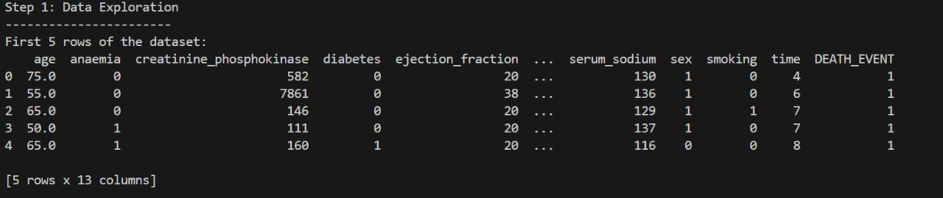

print("\nMissing values in each column:")
print(df.isnull().sum())
print("\nData types of each column:")
print(df.dtypes)
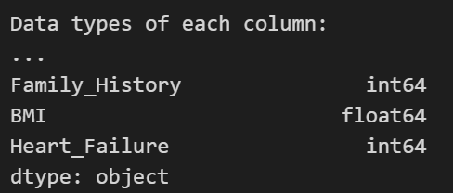
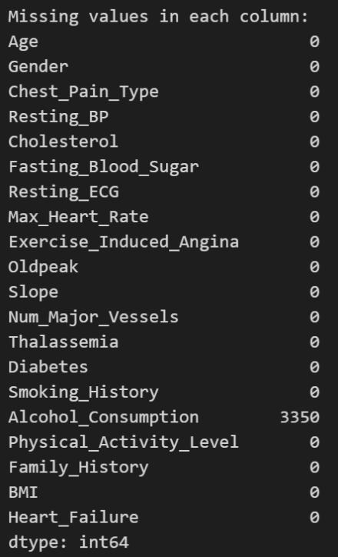

print("\nSummary statistics for each feature:")
print(df.describe())
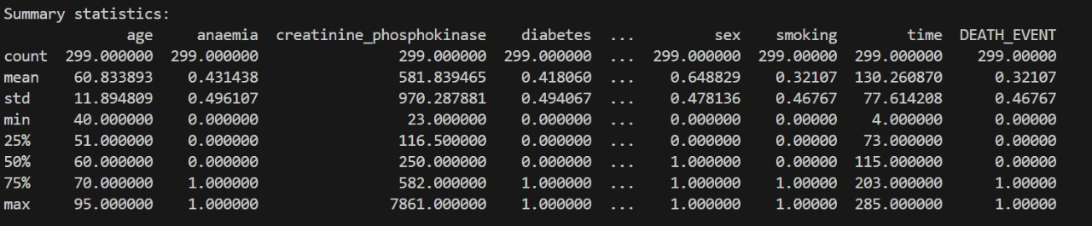

key_features = ['Age', 'Resting_BP', 'Cholesterol']
plt.figure(figsize=(15, 5))
for i, feature in enumerate(key_features):
plt.subplot(1, 3, i+1)
sns.histplot(df[feature], kde=True, bins=20)
plt.title(f'Distribution of {feature}')
plt.tight_layout()
plt.show()
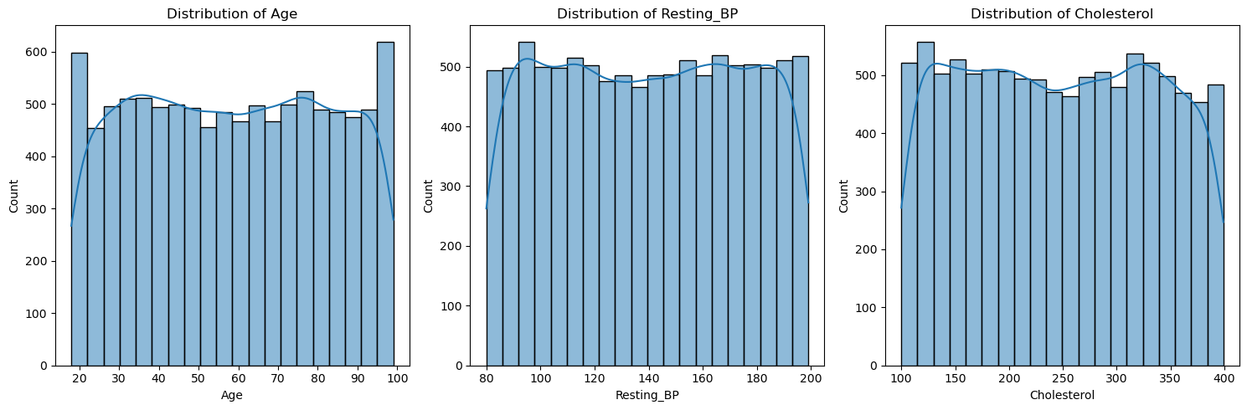
plt.figure(figsize=(6, 4))
sns.countplot(x='Heart_Failure', data=df)
plt.title('Distribution of Heart_Failure')
plt.xlabel('Heart Failure (0 = No, 1 = Yes)')
plt.ylabel('Count')
plt.show()

heart_failure_counts = df['Heart_Failure'].value_counts(normalize=True)
print("\nProportion of Heart_Failure values:")
print(heart_failure_counts)
if 0.4 < heart_failure_counts.min() < 0.6:
print("The dataset is relatively balanced in terms of the Heart_Failure variable.")
else:
print("The dataset is imbalanced with respect to the Heart_Failure variable.")

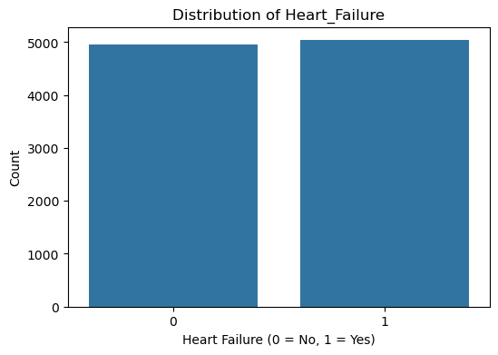
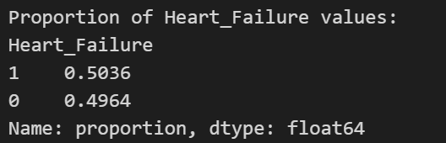

2. Feature Selection and Preprocessing

from sklearn.preprocessing import StandardScaler
import pandas as pd
# Drop the target column
X = df.drop(columns=['Heart_Failure'])
# Convert categorical columns to numerical using one-hot encoding
X_encoded = pd.get_dummies(X, drop_first=True)
# Standardize the features
scaler = StandardScaler()
X_scaled = scaler.fit_transform(X_encoded)
# Confirm shape and preview the scaled data
print("Shape of the scaled data:", X_scaled.shape)
print("\nFirst 5 rows of scaled features:")
pd.DataFrame(X_scaled, columns=X_encoded.columns).head()

Shape of the scaled data: (10000, 26)
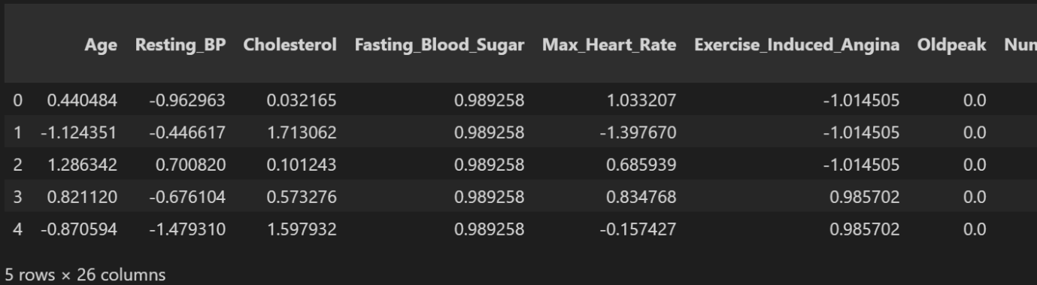

3. Dimensionality Reduction with PCA
from sklearn.decomposition import PCA
import matplotlib.pyplot as plt
# Apply PCA to reduce to 2 principal components
pca = PCA(n_components=2)
X_pca = pca.fit_transform(X_scaled)
# Print explained variance ratio
print("Explained variance ratio for each principal component:")
print(pca.explained_variance_ratio_)
# Create a scatter plot of the PCA-transformed data
plt.figure(figsize=(8, 6))
plt.scatter(X_pca[:, 0], X_pca[:, 1], alpha=0.7)
plt.xlabel('Principal Component 1')
plt.ylabel('Principal Component 2')
plt.title('PCA - 2D Projection of Dataset')
plt.grid(True)
plt.show()
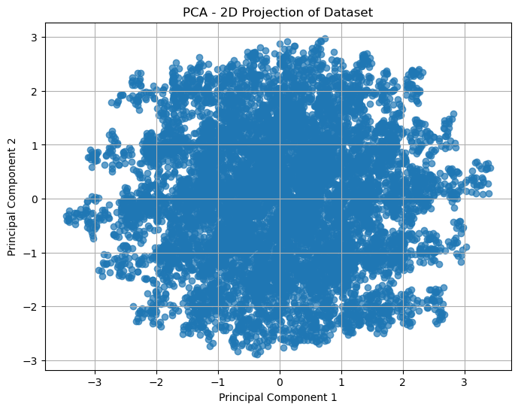
4. Clustering with K-Means

from sklearn.cluster import KMeans
import matplotlib.pyplot as plt
# number of clusters
n_clusters = 2
kmeans = KMeans(n_clusters=n_clusters, random_state=42)
cluster_labels = kmeans.fit_predict(X_pca)
# Add cluster labels to the PCA DataFrame for plotting
pca_df = pd.DataFrame(X_pca, columns=['PC1', 'PC2'])
pca_df['Cluster'] = cluster_labels

# Visualize the clusters
plt.figure(figsize=(8, 6))
colors = ['skyblue', 'salmon', 'green']
for cluster in range(n_clusters):
clustered_data = pca_df[pca_df['Cluster'] == cluster]
plt.scatter(clustered_data['PC1'], clustered_data['PC2'],
label=f'Cluster {cluster}', alpha=0.7, color=colors[cluster])

# Plot cluster centers
centers = kmeans.cluster_centers_
plt.scatter(centers[:, 0], centers[:, 1], c='black', s=150, marker='X', label='Centroids')

plt.xlabel('Principal Component 1')
plt.ylabel('Principal Component 2')
plt.title(f'K-Means Clustering with {n_clusters} Clusters')
plt.legend()
plt.grid(True)
plt.show()
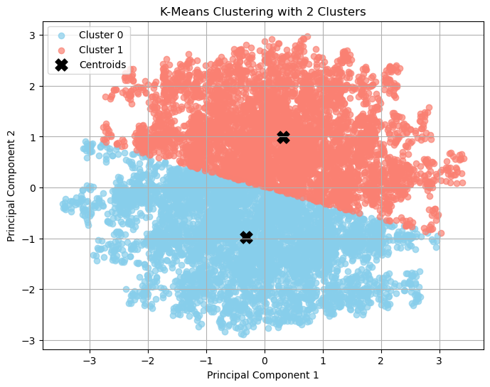

5. Interpretation
Reducing a dataset to two principal components using Principal Component Analysis (PCA) involves transforming the original high-dimensional data into two new synthetic features: Principal Component 1 (PC1) and Principal Component 2 (PC2). These components capture the majority of the variance (or important information) present in the original dataset. In simple terms, this process is similar to summarizing a complex book into two key paragraphs — while some details are lost, the core message remains. This dimensionality reduction enables effective visualization and pattern detection in a 2D space, making it easier to analyze and interpret the data.
For clustering, we used K-Means with 2 clusters. In the PCA scatter plot, we typically expect to observe two distinct groupings:
- If the clusters appear well-separated with minimal overlap, it indicates that K-Means has successfully identified meaningful patterns within the data.
- If there is noticeable overlap between the clusters, it may suggest that the data does not naturally divide into two distinct groups, or that more features may be needed for better separation.
Upon visual inspection of the scatter plot, the degree of separation between clusters can be evaluated. Since this dataset pertains to heart failure patients and we used two clusters, it is reasonable to hypothesize the following:
- Cluster 0 may represent patients at lower risk or those who did not experience a heart failure-related death.
- Cluster 1 may correspond to higher-risk patients or those who died due to heart failure (as indicated by the DEATH_EVENT feature).
It is important to note that K-Means clustering is an unsupervised learning technique and does not use the DEATH_EVENT label during training. However, we can compare the cluster labels with the actual DEATH_EVENT values to explore any correlations. If a clear relationship is observed, it would indicate that the clustering process has uncovered meaningful, real-world patterns among patient groups.

